ICT MARKET ANALYSIS DATA CONCERN INTEROPERABILITY
WITH FOCUS ON CONCEPTUAL BARRIERS
M.M.Matijevic¹, M.D.Matijevic¹
¹Mineco-Computers, Belgrade, Serbia

In order to improve and enable efficient interaction between education, research and innovation in the ICT area, referred to as a „knowledge triangle“, this paper propose the novel idea of introducing the market analysis and placing it in this triangle centre. Data collected from the ICT market, considered as „knowledge confirmed on the market as reality“, are analyzed from the point of triangle participants needs. The main challenge lies in numerous data sources and heterogeneity. The interoperability problem is analyzed, using barrier driven methodology and focusing on conceptual barriers, which are concerned with syntactic and semantic incompatibilities of information to be exchanged.

1. Introduction
In the last decades, science and technology have experienced an impressive advance. The new markets and/or the new products, such as new technologies, services or skills emerged. There is no doubt that the contribution of the ICT sector to GDP and employment has become more and more important (OECD 2001). The Lisbon agenda can be seen as the embodiment of a common model of socio-economic development, or a ‘‘world script’’, with an emphasis on science based innovation as the engine of economic development and education as a necessary investment in human capital. This script is contained in core political buzzwords such as ’’knowledge-based economy’’, ‘‘the Knowledge Institution’’, and ‘‘the New Economy’’ [1]. The Lisbon Strategy aims at developing Europe into one of the strongholds of the new knowledge economy through the “Knowledge Triangle“, whose nodes are higher education, research, and innovation.
Even though Europe is strong in ICT research, it lags behind other regions in turning research results to practice that is so-called innovation paradox. One of the numerous visible initiatives to overcome this paradox is the one that comes from EIT ICT Labs aiming to facilitate the integration of the “Knowledge Triangle” three sides: higher education, research and business. EIT ICT Labs is one of the first Knowledge and Innovation Communities set up by the European Institute of Innovation and Technology, as an initiative of the European Union.
The reasoning behind the proposed model development is in line with Nunamaker, Chen et al. (1990) who classify design science in Information Society as applied research that applies knowledge to solve practical problems. Problem-solution finding was carried out by adopting the barrier driven approach, aiming to detect and overcome the spotted barriers on every stage of designing process.
At the first stage of the model design in this paper, the overall business and technology framework was described with three main characteristics, which are considered as barriers to overcome. The first, industry clockspeed, is characteristic essentially driven by technological change and competition. The term is coined by Charles Fine (1998), showing that different industries and segments of them have their own pace of change in the life cycles of their products, production processes, structural makeup and CEO tenure. The second characteristic of today's business landscape is its complexity. According to Hodgson (2003), capitalism naturally leads to more complexity expressed as growing diversity of interactions between human beings and between people and their technology. At last, according to Wytenburg (2001, p.118) that "the greater the degree of complexity in an environment is, the more various, dynamic, and unpredictable are those situations", the growing uncertainty appeared as the third characteristic. Like every conceptualization, the business model concept aims at representing reality in a structured, simplified and understandable way, which could eventually help to better adapt to changes and to be better prepared for the future [2].
This paper is based on proposed novel concept, accomplished by innovation of the “Knowledge Triangle” in the ICT area. Innovation of “ICT Knowledge Triangle“, achieved by insertion of ICT market into its centre, enables the feedback among market, business, education and research. In the process of modeling the innovated ICT “Knowledge Triangle”, the focus is on modeling the ICT market analysis, with respect to the whole concept.
Due to the nature of ICT market analysis business process, which is primarily dealing with data and information, semantic interoperability based on ontologies approach is adopted [3].
Further research focused on registry model that relies on modern concepts of data structuring based on ontologies. Chosen concept requires creating domain ontology for particular area of ICT market analysis [4]. Following, in this paper, is presentation and description of the model architecture for semantic data integration for ICT market analysis.
2. Model for Data Integration
Solution development accomplished through barrier driven methodology resulted in adoption of combined approach. Consequently, both the integration of the existing information stored in relational database and MS Office Word and Excel files (“bottom up” approach) and developing new database are included (“top down” approach). Developing new database requires creating domain ontology. Proposed model is presented in the Figure 1 below:
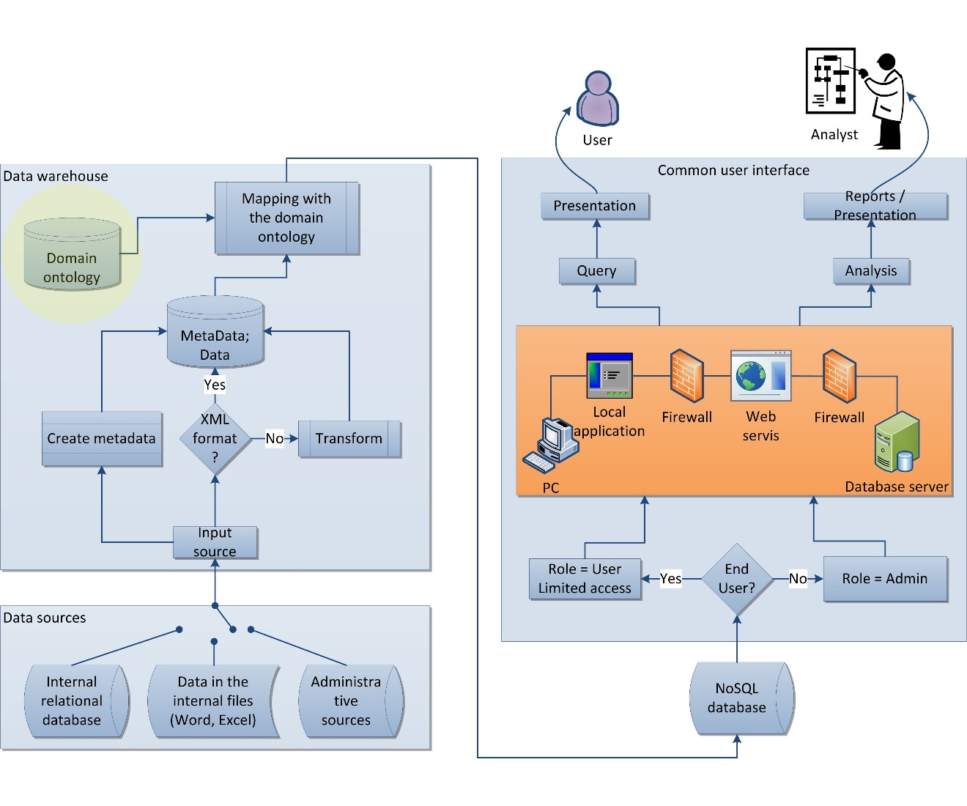
Figure 1. Model for Data Integration
Three main layers can be distinguished from the picture: Data Sources, Data Warehouse and Common User Interface. Separated NoSQL database is the “output” for data warehouse and the “input” for the common user interface and presentation level.
- Data Sources – In the proposed model, the main spotted barrier was incompatibility of existing data sources, so the sources are classified into three groups: Relational database; MS Office Word and Excel files and administrative sources (Serbian Business Registers Agency -SBRA, Statistical Office of Republic of Serbia, National Bank of Serbia - NBS). Each source group is analyzed separately.
- Data -The first requirement for any data integration is syntactic interoperability [5]. To achieve compatibility on heterogenic data, format for each data source is checked. XML format is proposed as standardized and commonly used format that is both human-readable and machine-readable. After this step, data from all existing sources are stored in a common database in XML format.
- Data Warehouse - is a collection of data which is organized to enable easy analysis, extraction, merge or other use of data for better understanding data essence.This data are called “information data” in the contrary to the operational data in transactional (ussually relational) databases. Two steps are accomplished to obtain “information data”: (1) metadata creation for each source and storing in the common database togather with XML data and (2) mapping the data from common database with the domain ontology for ICT market analysis.
- Metadata – or data about data include description of data elements (data types, data atributes, domain description, names, size and alowed values); data about data sources and data warehouse, authorizations for data access, business rules, etc. Metadata are the key for obtaining accurate, consistent information and for the sytem maitenance.
- NoSQL Database (proposed Graf Database) - People that are coming from traditional IT environment are used to idea of storing data in hierarchical (as XML) or relational Data Base (MySQL, MS SQL). In most cases, this concept is assuming that some elements are of more importance than the others are. Graf concept, and thus the Graf Database, consists of resources (nodes) in relation with other resources (nodes), irrelevant to their particular importance.
- User interface – enables user to access data which are stored at local hosted NoSQL database in the model architecture on Figure 1. In the proposed model user data acces is enabled through Web services.
- Analysis and presentation – NoSQL database is the starting point for different types of data analysis, as the results of data analysis should be delivered to the users. Access to data is enabled through the Web services. Although different type of users require different analitical and presentation tools, they can access the same, common database. The predifined user role defines the authorization level for accessing data. The basic analitical level is when user creates his own queries over data. From the existing categories of e-commerce applications [6] following are planned for the proposed model:
- Applications for reporting – enable statistical and parametrized reports.
- Аd hoc queries and reporting – enable user the highest level of interaction with data through offering number of techniques for data selection and navigation. Applications for analysis – also support ad hoc data search, but enabling realization of much complex multidimensional queries (with time/vendor/buyer/product/ dimension).
3. Semantic Data Integration in the Process of ICT Market Analysis
Unlike other technologies, which are dealing with data structure, the semantic technologies put the accent on understanding data. W3C Semantic Web is defined as Web of data, which is providing unique framework for sharing data among applications, entities and community [7].
Many authors suggest different definitions of Semantic Web. Some of the new theories consider Semantic Web as a web of information that can be used for operational work [8] and even more, Semantic Web technologies fit for solving the open-ended problems.
From two main distinguished approaches toward integration of semantic data interoperability and classification of semantic interoperability models [9], so-called material integration – Data Warehouse and decentralized “all to one” semantic interoperability model, are adopted for the purpose of the proposed model for ICT market analysis. This integration approach and semantic interoperability model secure ontology mapping rules that include semantic and concepts of all present sources, while integration logic is distributed. Dimensions of proposed integration model are presented in the Table 1.
Dimension of B2B integration | Dimension value
Common NoSQL Database | Database hosted on the local server
Common NoSQL DB Ownership | Ownership of Database creator
Application types for user interface | Windows application;  Web applications |  | Vertical Portal
Realization of application integration | Web Services and Service Oriented Architecture |  | Vertical Portal
Permission to access data | Limited access search and query (role: user) | Unlimited access (role: Administrator) | Vertical Portal
The way of using data | Query; data analysis, generating reports, without storing data in database
Periodicity | Arbitrary, when needed; ad hoc
Table 1 Dimensions of proposed integration model

3.1 Analysis of Data and Data Sources for ICT Market Research
Data sources are analyzed from the point of detected barrier: source dissimilarity. Existing sources are divided into 3 characteristic groups: relational DB, files, and administrative
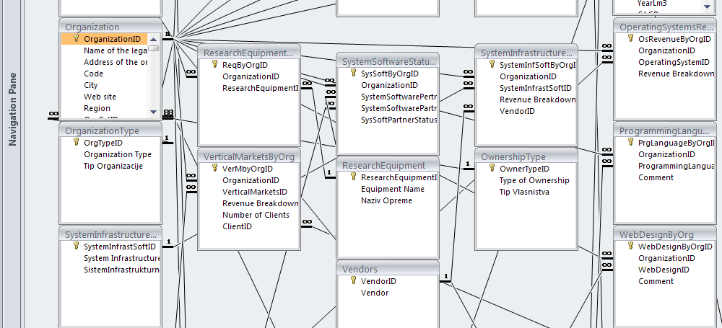
Figure 2. Relationships among tables
sources. Data analysis includes understanding the present data state, precise data definition, data architecture. The whole analysis is conducted from the point of data application, where data structure, logical and physical data model and data definition are necessary to have.
The example of existing relational database structure is relationships among tables on the Figure 2, while the Figure 3 presents the fields structure of the particular table Organization.

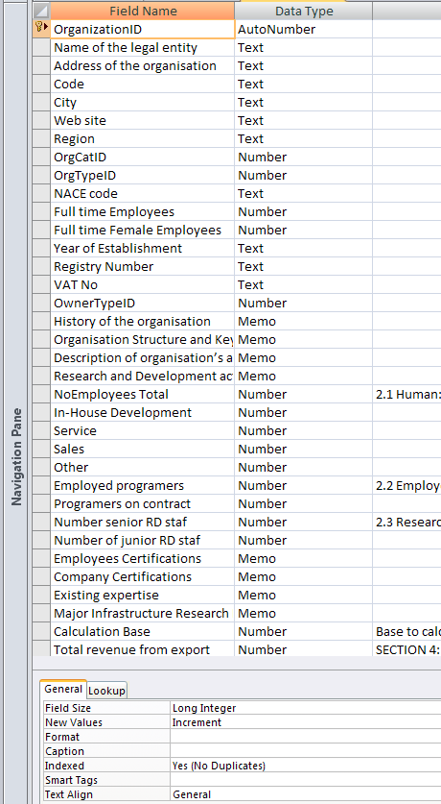
Figure 3. Fields structure for the table Organization
3.2. Process of Designing Domain Ontology
The ontologies are explicit formal specifications of the terms in the domain and relations among them (Gruber 1993). The Artificial-Intelligence literature contains many definitions of ontology [10] [11]; many of these contradict one another. For the purposes of this paper an ontology is a formal explicit description of concepts in a domain of discourse (classes (sometimes called concepts)), properties of each concept describing various features and attributes of the concept (slots (sometimes called roles or properties)), and restrictions on slots (facets (sometimes called role restrictions)). Ontology together with a set of individual instances of classes constitutes a knowledge base. In reality, there is a fine line where the ontology ends and the knowledge base begins. Ontologies has been moving from the realm of Artificial-Intelligence laboratories to the desktops of domain experts and become common on the World-Wide Web. Ontology defines a common vocabulary for researchers who need to share information in a domain. It includes machine-interpretable definitions of basic concepts in the domain and relations among them. The main reasons for developing ontology are: (1) to share common understanding of the structure of information among people or software agents (Musen 1992; Gruber 1993); (2) to enable reuse of domain knowledge; (2) to make domain assumptions explicit; (3) to separate domain knowledge from the operational knowledge (McGuinness and Wright 1998); (4) to analyze domain knowledge.
Basic questions for creation of ICT market analysis ontology and corresponding answers are:
- Which domain should ontology cover? – Domain of ICT market analysis (additional specification of the ICT market area is needed).
- For what purpose will ontology be used? – For faster and semantically rich data analysis in the process of ICT market analysis (and for the other entities in “ICT Knowledge Triangle”)
- What type of questions should ontologies answer? – Who? What? How much? sells/buys or offers/requires from products, services, expertise, skills, etc. (information needed for innovated “ICT Knowledge Triangle” members)
- Who will use and maintain the ontology database? At the beginning the analytical enterprise will use and maintain the ontology and ideally – anyone who would find it useful or interesting.
The questions that should keep in mind, too, are: does ontology contain enough information to answer assumed questions? Do the answers require some particular level of detail?
In semantic modeling, the following are important terms: Vocabulary - A collection of terms given a well-defined meaning that is consistent across contexts and Ontology - Allows you to define contextual relationships behind a defined vocabulary. It is the cornerstone of defining a knowledge domain. A formal syntax for defining ontologies is OWL (Web Ontology Language) [12], which is an extension to RDFS (RDF Schema) [13].The primary purpose of ontology is to classify things in terms of semantics, or meaning. In OWL, this is achieved by using classes and subclasses, instances of which in OWL are called individuals.
Diagram for the process of designing domain ontology for ICT market analysis, based on the methodology for creating ontology from Stanford university [14] is presented in the Figure 4.
In the proposed method for designing domain ontology the combined approach is accepted, which overcomes the barriers resulting from different sources. Combined approach specifies the most generalized, „top-level” concepts as classes and define all the belonging subclasses (top-down approach). Proposed model starts from creating most generalized concepts – classes such as: Business_Entity, Portfolio, Human_Resources. In the next step the class hierarchy (subclasses) is created like Business_Entity/Seller; Business_Entity/Finances; Business_Entity/General_Data or Human_Resources/Ekspertise, Human_Resources/Education_Level or Portfolio/Goods, Portfolio/Services. At the same time, the most specialized classes (instances) are identified at the lowest conceptual level and afterwards upper classes created, as for example, for the particular software MS_Office_Excel_2013/Microsoft/Brand/Application_Software/Software or HP1120/HP/Brand/Hardware/Portfolio/Business_Entity.

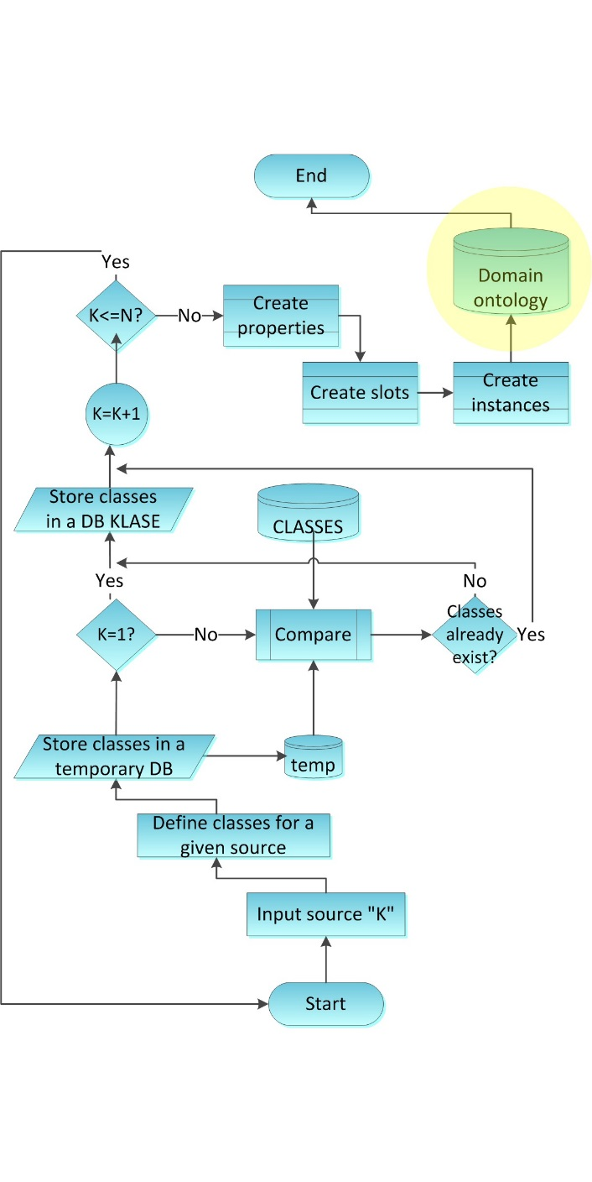
Figure 4. Diagram for the process of designing domain ontology
As seen from the diagram above, for each source input the set of classes and subclasses is created. At the end of the process, all the classes, which describe every input source, should exist.
After creating all the classes and their hierarchy subclasses the next step is defining properties. Class properties or slots are descriptions of the internal structure of concepts, as the classes alone will not provide enough information to answer the competency questions. All subclasses of a class inherit the slot of that class. Than the facets of the slots are defined.
Slots can have different facets describing the value type, allowed values, the number of the values (cardinality), and other features of the values the slot can take.
A value-type facet describes what types of values can fill in the slot (more common value types are: String, Number, Boolean, Enumerated, Instance).

4. Conclusion
Successful commercialization involves a number of critical factors such as links between technological discoveries and opportunities, demonstration of technology, resources and equity, market acceptance and selection of proper business development. The market analysis is seen as being a powerful tool for self-assessment, which helps to identify the most promising approach from amongst several possible technologies. Market is the most realistic check of sustainable growth and development through testing and selecting present needs for goods, services and skills, and creating new demands. It suggests direction for innovation and research as well as skill and education profile requirements that are in line with market needs and trends.
Understanding the role and importance of knowledge and innovation in the modern society, the presented work starts with the innovation of “ICT Knowledge Triangle” and focuses on the process of ICT market analysis. Relying on modern concepts of data structuring based on ontologies, this paper presents the model of architecture based on semantic data integration. This model requires creation of domain ontology for ICT market analysis. The procedure for creating domain ontology presented in this paper relies on methodology for creating ontology from Stanford University.
The proposed novel concept has advantages for the few main reasons: it is practical, it is pragmatic, it is not expensive, it does not include extra governance (and extra money for governance and supervision bodies) as it simply joins and connects existing resources (enabling efficient and understandable communication). It is simple in the concept. The realization can start from the simple model and develop in accordance to the reality providing the market feedback to all “ICT Knowledge Triangle” members.

Literature
- Meyer, J. W. (2000). Globalization—Sources and effects on national states and societies. International Sociology, 15(2), 233–248.
- A. Osterwalder, “The Business Model Ontology A Proposition in a Design Science Approach“, These, Universite de Lausanne, 2004.
- M. M. Matijević, M. D. Matijević, "Semantička interoperabilnost u procesu istraživanja tržišta informacionih i komunikacionih tehnologija", XIII Međunarodna konferencija E-trgovina 2013, Srbija, Palić, 24.-26. april 2013.
- M. M. Matijević, M. D. Matijević, Svetlana Jevremović,“Semantička interoperabilnost podataka u istraživanju IKT tržišta zasnovana na ontologijama“, Zbornik radova Infotech, Aranđelovac, 2013.
- Kim H. Veltman, “Syntactic and Semantic Interoperability: New Approaches to Knowledge and the Semantic Web”, Initially written for Dublin Core Meeting in 2000 which rejected the article. Published: The New Review of Information Networking, vol. 7, 2001.
- Bogdanović, Z., Despotović M., Miloradović N., Radenković B.,Poslovna inteligencija u e-obrazovanju, Etran 2007, Igalo 2007.
- W3C, “W3C Semantic Web,” 2011. [Online]. http://www.w3.org/standards/semanticweb/
- N. Shadbolt, W. Hall, and T. Berners-lee, “The Semantic Web Revisited,” IEEE Inteligent Systems, vol. 21, no. 3, pp. 96–101, May 2006.
- G. Vetere, M. Lenzerini, "Models for semantic interoperability in service-oriented architectures", IBM Systems Journal, 44(4), pp. 887-903, 2005.
- M. Uschold, M. Gruninger, "Ontologies: Principles, Methods and Applications" Knowledge Engineering Review , 11 (2), 93-136, 1996.
- T. C. Jepsen, “Just What Is an Ontology, Anyway?,” IT Professional, vol. 11, no. October, pp. 22–27, 2009.
- G. Antoniou and F.V. Harmelen, "Web Ontology Language: OWL", Presented at Handbook on Ontologies, 2004, pp.67-92.
- W3C, “RDF Schema,” 2004. [Online]. Available: http://www.w3.org/2001/sw/wiki/RDFS.
- N. F. Noy, D. L. McGuinness, "Ontology Development 101: A Guide to Creating Your First Ontology", Knowledge Systems Laboratory, Stanford University,CA, 2001.

