APPLICATION OF EXPERT SYSTEMS IN TECHNICAL DIAGNOSTICS OF MOTOR VEHICLES.
D. Vukić, I. Dunđerski, V. Matijević
School of Electrical Engineering and Computer Science Applied Studies, Belgrade, Serbia

This study presents the development of an expert system for use in technical diagnostics of motor vehicles. A set of examples was gathered on laboratory exercises at the School of electrical engineering and computer science applied studies in Belgrade. Data set analysis and determination of rules was carried out using Weka data mining software in Java. The web user interface (WUI) is based on eXpertise2Go expert system shell.

Introduction
During 1980s Bosch, Siemens, Magneti Marelli and other automotive manufacturers independently developed modern digital control systems for use on most types of vehicles. As the physical processes on vehicles are very slow compared to the speed of microcontrollers, there was a lot of free processor time to be used for other purposes than controlling the engine. That leaded to the creation of self-diagnosis systems. [1]
The expected advantage of self-diagnosis was the autonomus detection of faults on the vehicle systems. It was supposed that the automotive technicians didn't need to determine the reason of the problem any more, but to simply replace the defective part. Sadly, the praxis proved this expectations to be wrong. Even nowadays with the improved sensors and microcontrollers only around 25% of faults are properly determined by the self-diagnosis system. In other cases a skilled technician is needed to determine the source of the problem with or without informations given by self-diagnosis system. Education and specialization of an automotive technician is a long process and significant expense for eather small or large automotive company. In response to the market demands automotive software developers included guided troubleshooting into existing software solutions.
The main disadvantage of guided troubleshooting is the fact that it wasn't created by experienced technicians who solved the particular problems but by engineers. The result is that there are no specific problem solutions for the exact vehicle model. The only given informations are the generalized and hypothetical conclusions based on recurson of if-then algorithm.
Laboratory exercises
On the School of electrical engineering and computer science applied studies in Belgrade exists a study program Automation and vehicle control systems. The courses associated with automotive subject matter besides theory lectures include compulsory laboratory exercises. The objective is to acquaint students with real-life malfunctions on a vast range of vehicles. During past few years over 100 different pasenger cars and vans were the subject of diagnostics and experimenting. Most of the vehicles came with at least one problem. The causes of the majority of problems were determined and the solutions to those problems were recommended to the vehicle owners. Furthermore the records describing the problems and the causes were kept. The records include owners complaint, discriptions of diagnostic steps with additional diagnostic software screenshots. The screenshots contain live ECU (Engine Control Unit) data, oscilloscope snapshots, fault codes etc. These documents hold enough data for an experienced automotive technician to conclude the reason of the malfunction without performing tests themselves. As mentioned, in the course of the diagnostic process different dedicated testing softwares were utilised. For example Fig 1. depicts the way of conducting a relative compression test by way of measuring starter current during prolonged engine starting.
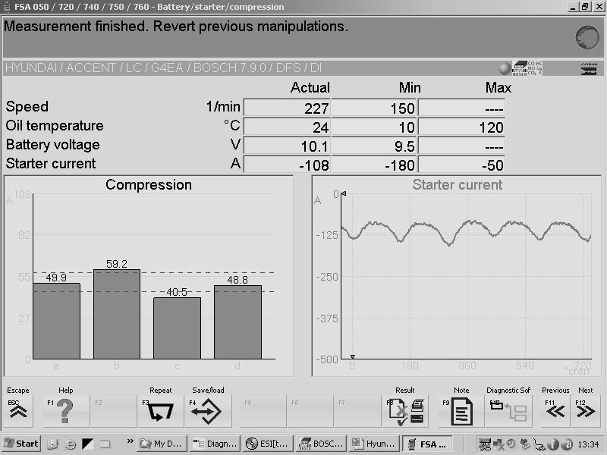

Fig. 1. Relative compression test
Set of examples
When creating a set of examples it is of utmost importance to properly define attributes. Too many attributes with little relevance may result in ambiguous conclusions. Too few attributes and there will be no conclusions at all. With complete diagnostic records in which the emphasis is on the tests that leaded to the cause of the problem it is not too difficult to extract the right attributes. Nevertheless, a lot of knowledge and experience is needed to separate the important information from the rest. Looking through the records it may be noticed that some tests recur more than other and that the results of these tests often uncover the root of the problem. After a few iterations the following attributes distinguished:
- fuel type – the type of the power source either fuel or electric energy. The values are: gasoline, diesel, LPG, hybrid and electric;
- compression pressure – measuring compression pressure shows the overall condition of engine cylinders, pistons, piston rings, piston rods and valves. The measurement has two results: compression pressure greater than the minimal value and lower than minimal value. In the set of examples this values may be represented with normal and low respectively;
- cylinder leakage – this measurement is similar to the measurement of the compression pressure. The difference is that it may be determined where exactly is the compression pressure leaking. Therefore cylinder leakage test is usually performed if the measured compression pressure is low. The important notice is that if compression pressure is low the leakage doesn’t have to be high, but high leakage is a certain indicator that compression pressure is low. The values in the set of examples are: low, inlet valve, exhaust valve and cylinder/piston/rings;
- blue exhaust smoke – presence of blue exhaust smoke allude to the consumption of engine oil. The values are true and false.
- black exhaust smoke – a lot of carbon particles colour the exhaust fumes black. This is a certain indicator that the fuel mixture is too rich. The values are true and false;
- fuel consumption – there are many reasons for high fuel consumption. Coinciding with another symptom narrows the possibilities. The values are high and normal;
- cranking – when turning the ignition lock to the start position the engine should start turning which sounds loudly. The absence of cranking (turning) usually implies that there is something wrong with electrical installation. This attribute is closely tied with the next two. The values are true for cranking and fault if nothing is happening;
- battery voltage drop – if battery voltage is high enough but drops considerably when starting the engine then the battery is worn out. The value true stands for the presence of voltage drop and false means that the voltage is stable during cranking;
- starting – engine starting process can be successful and unsuccesful. The values are true and false respectively
- starting temperature – for the cases when the engine doesn’t start the temperature is an important information, especially for diesel engines. It also makes a difference when diagnosing starting failure on gasoline engine when the spark is missing. The values are low and operating;
- misfire – a misfire is the absence of mixture ignition inside the cylinder. The reasons are many and the values are true if the misfire occurs and false if it doesn’t happen;
- knocking – knocking sound from the engine is commonly the effect of early ignition. The damage it can inflict to the engine is immense. Similarly to the previous attribute if knocking occurs the value is true and if it doesn’t the value is false;
- spark – on gasoline engines there are two main requirements for successful starting and running: fuel and spark. The values are true for the presence anf false for the absence of spark;
- fuel pressure – fuel pressure needs to be high enough for engine to start and run smoothly. The value normal stands for adequate pressure and low for pressure lower than expected;
- vibrations – vibrations evaluation is the basic diagnostic test. If the engine vibration level is high the value is high and if it is normal the value is normal;
- performance – it is very dificult to rate the engine performance since it depends on subjective assessment of owner or tecnician because the measurement equipment is very expensive. However, this information is often significant and should be taken into account. The values are normal and poor;
- overheating – if the engine is overheating the value is true otherwise the value is false;
- cause – finally, this attribute tells the reason of the malfunction. Since the engine and control system are complex the list of values is adequately long. The values are: IV (inlet valve), EV (exhaust valve), spark plugs, glow plugs, crankshaft sensor, injectors, ECU, cylinder mechanically, ignition coil, fuel pump, battery and starter.
With the attributes defined the next step is to classify the examples and build the ARFF file type database. There are a few ways of creating the dataset and the chosen one is by using text editor and Weka Explorer application. In ARFF database the examples are written in rows with values separated by commas. Therefore it is easy to edit the set of examples in a spreadsheet application using text to columns function and saving data as CSV (comma separated values) file type.
Machine learning
Since the objective is to create an expert system for assistance in technical diagnostics the derived rules must come with an explanation. The C4.5 alghoritm developed by Ross Quinlan uses the concept of information entropy to build a decision tree. [2] In Weka Data Mining software a classifier named PART is used to build a partial C4.5 decision tree in every iteration. The most certain leaf of every decision tree is then turned into a rule. For the gathered dataset the PART classifier generated the decision list presented in the Table 1:
Table 1. The decision list

Rule № | Rule desscription
Rule 1 | cranking = false AND battery voltage drop = true: battery (10/0)
Rule 2 | cranking = true AND starting = false AND fuel pressure = low: fuel_pump (7/0)
Rule 3 | cranking = false AND battery voltage drop = false: starter (7/0)
Rule 4 | compression pressure= low AND blue exhaust smoke = true: cylinder_mechanically(7/0)
Rule 5 | black exhaust smoke = true: injectors (5/0)
Rule 6 | fuel type = diesel AND cranking = true AND starting = false AND starting temperature = low AND fuel pressure = normal: glow_plugs (3/0)
Rule 7 | fuel type =gasoline AND cranking = true AND starting = false AND starting temperature =operating: crankshaft_sensor (3/0)
Rule 8 | fuel type =gasoline AND cranking = true AND starting = false AND starting temperature =low:ignition_coil (3/1)
Rule 9 | knocking = true: spark_plugs (3/1)
Rule 10 | : ECU (5/2)

Web user interface
The translation of rules to the eXpertise2Go expert system shell is very simple. There is no need for more than basic programming skills. First the rules are written using the notation shown in the following example:
RULE [Battery]
IF [cranking] = "No" AND [battery voltage drop] = "Yes"
THEN [The cause and recommendation] = "Battery defective. Replace battery." @ 100
Where the last number is the prediction certainty in percents. Then the questions are defined similarly:
PROMPT [cranking] MultChoice CF
"Is the engine cranking?" "Yes" "No"
Finally, the web user interface layout parameters are defined and the Expert system is ready to use as displayed on the Fig. 2.

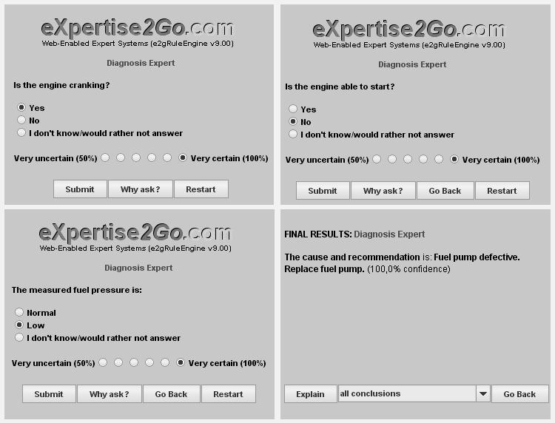

Fig. 2. Expert system web user interface (WUI)
Conclusion
This paper describes the early development of an Automotive diagnostic expert system. Though the dataset is relatively small the resulting decision support system is already useful for teaching students. The next step is creating a service network where the users both benefit from the expert system and improve it by sending useful informations.
Literature

[1] Robert Bosch GMBH, Gasoline-Engine Management, 3rd edition

[2] John Ross Quinlan, C4.5: Programs for Machine Learning

