THE PROGRAMMING LANGUAGE MATLAB AS A FUNCTION OF DIGITAL STEGANOGRAPHY TECHNOLOGY
S.G.Minić¹
¹University of Pristina-K.Mitrovica, Faculty of Teacher Education-Leposavic, Serbia

Abstract -This paper describes a technique by which messages can be hidden within digital media using MATLAB programming language. Steganography is exactly maintaining the confidentiality and privacy of critical information and protecting them from potential sabotage, theft or unauthorized access.
Despite the large number of steganography carriers and methods provided by digital technology, images, audio, and video are still the most common and the most appropriate digital carriers, and there is the largest number of steganography techniques developed for them.
Keywords - stenography, MATLAB, engineering, program, functions

Introduction
There is a large number of different techniques through which messages can be hidden within digital media. One way is exploiting of unused parts of files or unallocated memory space for storing secret data which can also be directly accessed. Small quantities of data may be hidden within the unused parts of the header files. If partition is not visible in standard conditions, then there are some tools which at the same time can allow full access. Although there are many steganografskih holders and the most popular method will be described in the rest of this paper.

Systems based on the substitution
The basic principle of the system based on the the substitution is the replacement of redundant parts of the image with secret data. For understanding of this principle it is very important knowledge of the steganographic holder structure, and we give a brief description of the RGB (Red-Green-Blue) systems. Within the RGB system, each color is represented by the relative intensities of each of the three existing components, red, green and blue.
Each RGB component is determined by a single octet, ie. a series of 8 bits, so the value of the intensity of each of the three colors can range from 0 to 255. Since the RGB system contains three components, this method of presentation, we get the 24-bit scheme which supports 16,777,216 unique colors.
Most of today's applications for processing and displaing images described supports 24-bit scheme, but allows the use of 8-bit scheme to save the image size. Such a scheme actually also uses 24-bit color pixels, but additionally has a palette that specifies color used in the image. Each pixel is coded with 8 bits, where is that value indicated by the records desired color in the palette. Therefore, this method limits the number of used colors in the image at 256 for 8-bit display color index in the palette. 8-bit pattern is typical for GIF (Graphics Interchange Format) image formats which are generally considered a lossless image compression.

Substitution of minimum important bits
Substitution of minimum important bits (of the least significant bit substitution; LSB substitution) is the most common steganography technique used in steganography work with multimedia files. The term "minimum important bit" is associated with the numerical importance of the bits in the octet. The bit of maximum importance is with the highest arithmetic value (12810), and the bit of minimum importance is with the lowest arithmetic value (110). Change of minimum bits has importance effect in all octets that make up a multimedia file. The described principle is even more effective due to the fact that the human optical composition is not sensitive enough for Recognising these changes in color. The idea steganographic techniques substitution bits least importance is based on breaking the secret messages on bits which are then kept in place for at least important bits in selected octets. As a simple example of LSB substitution is shown hiding the letter 'G' in the next series of bytes:

10010101 00001101 11001001 10010110
00001111 11001011 10011111 00010000

The letter 'G' is the ASCII (American Standard Code for Information Interchange) standard recorded as a binary string 01000111. These 8 bits are written to the position of the least important bits in the original set of bytes:

10010100 00001101 11001000 10010110
00001110 11001011 10011111 00010001

In the mentioned example actually changed only half the bits of the least importance. LSB substitution is steganographic techniques whose application is often not so simple. In fact, if a set of bytes into which is inserted through secret messages will choose the easy way, for example, a series of adjacent bytes in the beginning of the file, it is very likely that this part of the images have different statistics from the rest of the image, and as such will draw attention to themselves and compromise the secrecy of the hidden messages. Therefore, the set target octet often defined by a method of random selection as one of the factors that make detection steganografskih messages extremely complicated. Followed an example of hiding one image to another, using the given algorithm. Data is a MATLAB function. Display functions LSBSkrivanje:

function [Stego, Perceivig] = LSBHiding (Holder, Hidden, n)
% Hiding photos of N bits of minor importance Bearer

Stego = uint8(bitor(bitand(Carrier, bitcmp(2^n - 1, 8)) , bitshift(Hidden, n - 8)));
Iscitana = uint8(bitand(255, bitshift(Stego, 8 - n)));

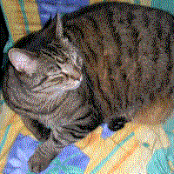 | 
Picture 1 – Holder: cat.bmp | Picture 2 – Hidden Picture - viktory.bmp

Sova = imread('cat.bmp', 'bmp');
Pobeda = imread('viktory.bmp', 'bmp');
n = 4;
[Stego, Ekstrahovana] = LSBHiding (cat, viktory, n);
figure, imshow(Stego)
figure, imshow(Ekstrahovana)

Calling functions in Matlab, LSBHiding display the results

 | 
Picture 3 – Stegano | Picture 4 – Exstracted

LSB substitution shows good results in working with black and white images. If you hide data within 2 bits of least importance, the human eye still does not see the difference. Unfortunately, the LSB substitution is sensitive to the slightest operations on images, such as compression or remove some parts of the image. For example, converting GIF or BMP steganographic files in JPEG format, and converting back to the original format may destroy the information in the least important bits. LSBSkrivanje is formed using the built-in MATLAB functions bitand, ther and bitshift. The other two tehinke that will be presented hereafter are less able to rely on the Matlab as environment.

Sorting pallets
Many of the images use color palettes used in the image. Pallets, of course, contain only a subset of the entire color space in 24-bit display, and every color in the palette was presented with a 24-bit vector that defines the RGB values ​​of the color index, ie the location of the pallet. This index is stored within each pixel images and use it to determine the appropriate color pixels. The first step in the implementation of this steganographic techniques is making copies of the original color palette and change of location in the new color palette. The new color scheme is determined by the colors that are close to the RGB system, are in near range. Then applies a standard LSB substitution, that will at least importance within each pixel is replaced by bit secret messages. At the end of the respective RGB colors identified in the original pallet, so its index in the original array is used as the new value of the pixel.

Domain transformations
Transformation domain in steganography technique is based on hiding data using mathematical functions. Mathematical functions are used in compression algorithms. The basic principle is to insertion bits of secret messages to place the least importance coefficients. Specifically, the JPEG image format used discrete cosine transform (discrete cosine transform - DCT) coding instead of individual pixels. Photo split into 8x8 blocks for each component of the RGB system. The goal is to find blocks in which the amount of changes of the low pixels to the entire block is replaced by a discrete cosine transform coefficients. If the amount of change is too high, the block is divided into 8x8 smaller blocks until the amount of the change is not low enough. JPEG format is considered a image compression with losses. The Image is not quite identical to its original image which is obtained with conversion. JPEG steganography as bearer performed change the relation of these coefficients instead of bits in the LSB substitution.

Masking and filtering
Masking and filtering techniques are typically used only on 24-bit black and white images. They are also used to insert a digital watermarking. In the work with JPEG images this technique is more appropriate than LSB substitution. Image processing is used in the protection against losing insert information.

Models of extended spectrum
Models spread spectrum signal using a wide range. The message that the input signal is a narrow spectrum. Secret data is spread across parts of the carrier having the greatest importance, and thus make it difficult its detection and jamming. These models are based on the fact that small distortions in the picture or sound files discover the hardest parts of the carriers carry the highest energy. This is a very popular technique in the field of digital watermark.

Binary image
Binary images (i.e data obtained by fax) contain a certain amount of redundancy in the distribution of black and white pixels. Simple LSB substitution does not give good results with these images, but it is possible to take advantage of their redundancy and insert the secret information by using the number of black pixels in a specific part of the image.

Changing pixels
The most effective technique is the technique of changing pixels. This technique changes the ASCII value of a certain number of pixels. Each pixel has its own 3 octets, for all three colors at a time. If instead some of the color entries ASCII value of the characters in this pixel, the content of the image would change , but the human eye would not have objected if using appropriate image. Followed display of MATLAB functions that serve to hide and later reading the string from the image, according to a key agreed.

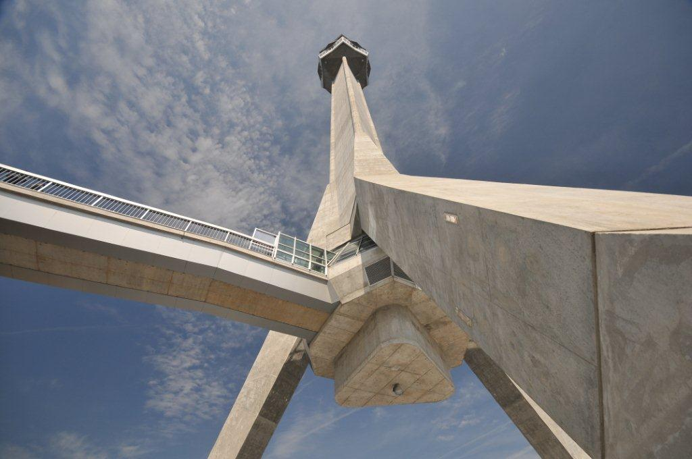
Picture 5 – The holder of hidden information in a given example

function hide (length, string, image)
% NI = new image
% string = of information that inserts
% nameImages = picture behind which hide

I=imread(image);
[n,m,t]=size(I);
s=uint8(string);
s=[s 0];
s=uint8(s);

slika=I;
br=0;
for i=1:n
for j=1:m
if (rem(i+j,25)==0 & rem(i,21)==0 & rem(j,14)==0)
if (br==duzina)
break;
end
br=br+1;
slika(i,j,1)=s(br);
slika(i,j,2)=s(br);
slika(i,j,3)=s(br);
end
end
end
imwrite (picture, 'slika.bmp');
impixelinfo (imshow (image))
end

Example of changing pixels - display function code
Hiding (22, 'The Legend of Johnny Cash', 'Diablo.bmp')

Picture 6 – Stego

unction record = read (length, image)
%function which we read hidden information
%string it is in what we record read
%image is an image from which we read

I=imread(image);
[n,m,t]=size(I);
picture=I;
br=0;
record=[];
for i=1:n
for j=1:m
if (rem(i+j,25)==0 & rem(i,21)==0 & rem(j,14)==0)
if (br==duzina)
break;
end
br=br+1;
record =[ record picture(i,j,1)];
end
end
end
record =char(record);
end

Conclusion
Steganography has a highly efficient and powerful techniques that allow people to protected and hidde communication. Combined with cryptography, an additional layer of security to protect the information. Steganographic technology is very simple to use, and extremely difficult to detect. In recent years, steganography was the subject of many discussions related to its abuse, especially in terrorist activities.
In the past years, steganography has been the subject of many discussions related to its abuse, especially in terrorist activities. So in many legal authorities is growing concern about the use of steganography to share illegal material via multimedia files on websites. Steganalysis a much younger discipline of steganography. Today there are different stego methods by which we can successfully detect and prevent such criminal activities.
On the other hand, there are many advantages of using steganography in legal context, such as digital watermarking to determine ownership of copyright or safer methods of storing important and confidential information, therefore, in future more intensive development of the technology and the wide application possibilities.
Matlab has big opportunities for graphical data, vectors and matrices, and the notation and print these diagrams. There are high-level functions for 2D and 3D data visualization, image processing, animation.

References
1. Wikipedija, http://en.wikipedia.org/wiki/Steganography
2. Steganography & Digital Watermarking, http://www.jjtc.com/Steganography
3. http://www.studentskisvet.com/include/template/stampa.php
4. http://www.securityfocus.com/infocus/1684
5. http://www.petitcolas.net/fabien/steganography/
6. http://www.tech-faq.com/steganography.shtml
7. http://os2.zemris.fer.hr

