LEVERAGING INTERNET MARKETING CAMPAIGNS THROUGH SOCIAL NETWORK ANALYSIS.
Vojinović I., Vukmirović A., Despotović-Zrakić M., Milutinović M., Simić K.
Faculty of Organizational Science, University of Belgrade, Serbia

This paper presents a method of applying social networking and semantic Web technologies in internet marketing. The research subjects are methods and principles of data collection from social networks and their subsequent enrichment with semantic Web technologies using several Web services and APIs. Current trends, practices, problems, and limitations of direct marketing are analyzed, and used to enhance the marketing processes. The model is implemented and tested by developing and using a Web application in direct marketing processes of Faculty of Organizational Sciences.

1. Introduction
Social network sites such as MySpace, Facebook, Twitter and LinkedIN have attracted millions of users since their appearance. People have integrated these sites into their daily practices. Social media is extremely popular at present and its monetization has been discussed in publications but not in details. The most frequently used approach to making money using social media is online advertising [1].
Marketing on social networking sites (internet marketing), is not a substitute for traditional marketing and should be treated as a complement to other marketing activities. Social media networking is part of a trend known as Web 2.0. Its expansion changes the way users and developers use Web, and has a tremendous impact on the way companies conduct marketing.
Social marketing is a popular and effective way of getting information essential for the success of business. One of the most important advantages of social networks, which can contribute to the success of the companies, is creating an interactive contact with the customers. It gives the companies an opportunity to talk with customers on a personal level. They can gain a better understanding of the customer’s needs and requirements by directly following them. They can use this information to build effective relationships with customers, which is usually difficult or impossible to achieve through traditional marketing methods. The challenge is to use all information in an appropriate manner and in a meaningful way for the company. One of the benefits of marketing using social networks is that social marketing can be an inexpensive way to promote a company rather than putting together a huge marketing team or a prohibitive budget.
This paper presents a model for utilization of social networking for gathering data about target groups and execution of Internet marketing campaigns. The main goal of this paper is the improvement of Internet marketing processes by using social networks. In order to achieve this goal, the processes of data gathering, presentation, semantic enrichment, and direct marketing are utilized. The model is implemented and tested by developing and using a Facebook application in direct marketing processes of Faculty of Organizational Sciences’ E-business Lab.

2. Theoretical background
Web 2.0 presents technologies that enable users to communicate with each other, to create, organize and share any type of content using social networks [2]. There is an explanation why Web 2.0 is social media that holds such potentials [3]. Firstly, Web 2.0 applications engage customers in creative process by producing and distributing information through writing, content sharing, social networking and social bookmarking. Secondly, it also encourages viral marketing – dissemination of marketing messages by the customers. The time needed to exchange experiences between large numbers of users is also reduced. Web 2.0 presents a variety of networking tools and technologies that emphasize the social aspects of the Internet as a channel for collaboration and communication [4]. Social media include Internet based applications with technological foundation of Web 2.0 that enables creation and exchange of user generated content [5]. Based on their application type social media could be divided into five categories: blogs and podcasts, social networks, communities, content aggregators, virtual worlds [6].
Social network sites are Web-based services that enable people to build public or semi-public profiles within a limited system and to declare a list of users with whom they would like to share their interests [7]. They represent virtual spaces for social interaction, public affirmation, and making relationships with friends or colleagues. Online social networks can be described as a global virtual community that connects a group of people in one place where they can exchange ideas and opinions, communicate, chat, date, make a business or personal contacts or maintain existing relationships. Structure of the social networking sites is made out of members, that can be represented as nodes on a network graph, that share interests such as ideas, friends, Web links, likes, dislikes [8].
Companies can use social media in a various ways for business purposes [6]. For the beginning, companies have to understand all the options that social media have to offer and include them into PR ability. It is important to target potential market and reach online customers by PR, who should pass messages about products and save costs compared to traditional marketing approach. Following step is actively listening the customer's thinking. People like to exchange experiences about products or services that they used, and compare expectations and opinions after testing it, through forums, blogs, and online communities. All this information is high quality and low cost market resource for the company. Utilizing social media as direct and personalizing one-to-one marketing tool should help companies to increase interactions with customers.
There are key questions that have to be considered before launching social media strategy for product or service promotion [3]. First one is for those conducting promotion. It is important to know priorities of targeted population, also to identify level of how often population using social media and consider their habits and behaviors while using it. Cost-benefit analysis should present to the company the financial costs associated with social media approach and to inspect possibility of reducing costs using social media marketing. Companies have to reconsider how social media implementation suit and improve corporate objectives and corporate strategy, and how difficult is to implement it.
Web 3.0 is the new perspective of the World Wide Web that helps transform Web sites into Web services, unstructured information into structured information, and replace existing software platforms with a new generation of platforms as a service. Web 3.0, the third generation of Web technologies and services, is about meaning of data and accents a machine-facilitated understanding of information on the Web. The development of Web 3.0 focuses on adding metadata or information to describe the content of the Web, which provides an intelligent level to the Web site, enables user to communicate completely with the machines and enables machines to communicate with each other. The Semantic Web idea emerged from the confluence of several communities such as artificial intelligence, hypertext and Web developers. The Semantic Web is an approach to encoding and publishing information in ways that makes it easier for computers to understand. DBpedia is a site that can be considered a flagship of semantic web. It contains data from the better-known Wikipedia site in a semantically annotated form intended for use by the machines. DBpedia analyzes the Wikipedia's pages, extracts and publishes structured data from them. DBpedia was extended with a live extraction framework that allows direct changes of the knowledge base. Live extraction framework has a capability of processing tens of thousands changing per day in order to consume the continuous stream of Wikipedia updates [9].
3. Social networking-based model for Internet marketing campaigns
Social networks represent an excellent medium for improving the performance of educational institutions on the Internet, the reputation and image creation [10]. In this paper, we present an improved model of conducting internet marketing campaigns that is based around acquiring information from the Facebook social network and using it to directly target a specific group of individuals. The presented model was applied at the E-business Lab by designing a simple implementation based on an existing Facebook application in order to test the feasibility of presented model. This implementation was used to develop an experimental marketing campaign for the E-business Lab. The campaign targeted students and graduates of undergraduate programs that could potentially be interested in attending master and doctoral studies offered by the E-business Lab.
The main idea is that a Facebook application, offering some useful service to the users, can also be used to collect data from them and use it as a basis to construct a generic profile of a target group. The marketer can then utilize this profile in the decision-making process in order to generate appropriate marketing ads. Collected data is stored in the database and is used to single out common characteristics of potential users of a product or service that is offered by the owner of the application. The list is forwarded to marketers and presented visually using graphs; the marketers can review it and choose a target group for direct Facebook advertising according to the common characteristics identified in the data set. Marketers can further enrich available data using DBpedia or another similar linked data repository, and gain new understanding about the data. The application itself can also make direct posts on the users timeline if a more direct marketing approach is desired. These posts can be made based on some predefined logic, or initiated manually by the marketer; the second option is preferred since all interaction needs to be performed carefully. The model is presented in figure 1, with some elements in the model represented using screenshots from the actual implementation that is outlined later.
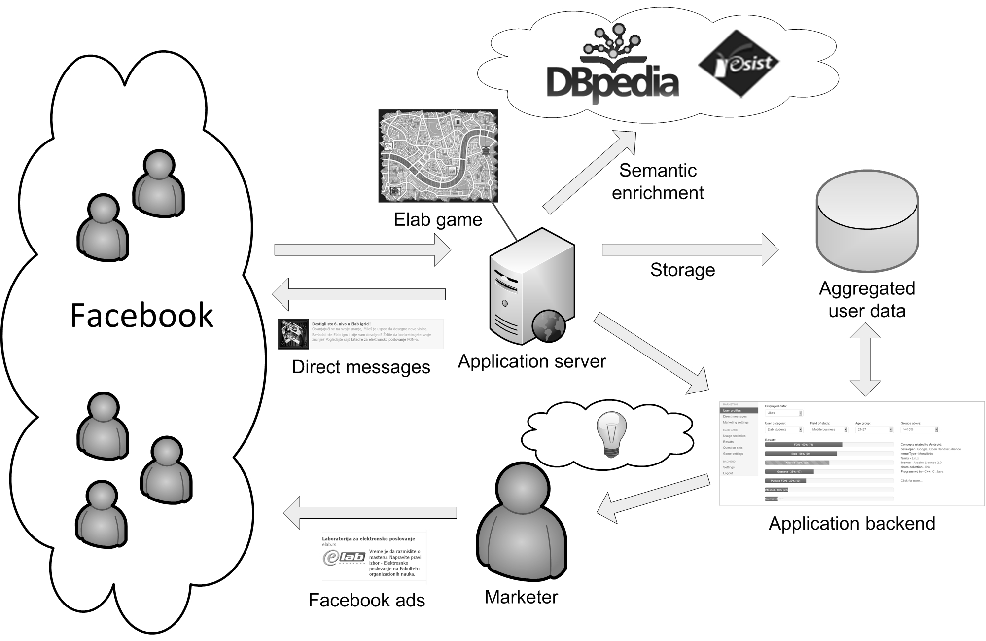

Figure 1. Model of Internet marketing campaign
The campaign that was developed based on this model took into consideration the characteristics and constraints of the educational context, and the existing courses offered by the E-business Lab. E-business Lab conducts courses on all levels of studies (undergraduate, master, PhD) and provides students with various services in the area of internet technologies. Its primary goal is improvement of teaching and learning processes by using modern technologies and utilizing distance education to support traditional methods of teaching. In accordance to its goals, the E-business Lab possesses an educational Facebook application that allows Facebook users to go through some of the E-business Lab’s educational materials in the form of a game. This application was adjusted to implement the presented model.
The application uses environment familiar to the students (Facebook) and the edutainment principle to make learning easier [11]. It can be accessed both by the students enrolled in E-business Lab’s online courses, and by other individuals on Facebook. The first group of users is identified automatically by their e-mail address by comparing it those used for E-business Lab’s online courses. If the email is not found, the user is assumed to be from the second group. When the application detects the type of the user, it assigns questions of suitable difficulty from the Moodle database. Users not enrolled in Moodle courses are presented with easier questions as a method of introduction to the field of study. This simple, fun way of presenting educational content enables them to become familiar with E-business Lab’s courses and, perhaps, enroll in its master or doctoral programs.
The game starts when the user selects a field of study he is interested in. The game then presents available tests, the “library” where teaching materials can be accessed, and other options – finding other users in the game, viewing a high score list, inviting friends to play, or using the forum or the help desk to discuss the game. When enough correct answers to questions are given, the user can proceed to the next level. The questions themselves are extracted from the existing E-business Lab’s electronic courses. User’s level is displayed on a special map and the progress spends his “energy”, which can be replenished in a “virtual shop” and the “reading room”, with both offering some additional features to the user. When users that do not attend E-business Lab’s courses finish the game, they receive suggestions about courses that would suit them best. The suggestion is based on their results; if they achieved good results, links to appropriate E-business Lab’s courses are supplied; if the results were not so good, links to some basic educational resources used in E-business Lab’s courses are given.
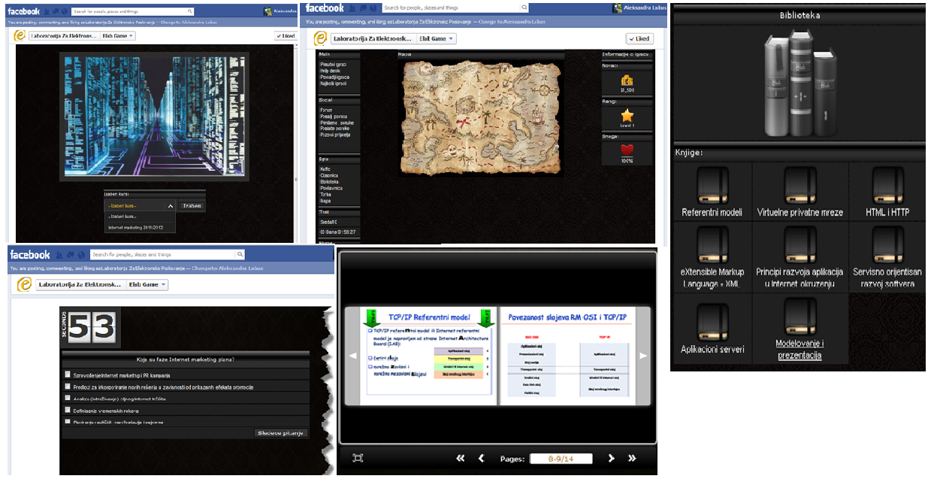

Figure 2. Different screens of the E-business Lab Game application
This application was improved to collect relevant data from the users Facebook profiles. Naturally, users are asked for consent upon installation of the application, and are also reminded about the privacy policy every time they access the game. The policy states that information stays confidential and is not traceable back to the individual user, being only stored and used anonymously, in the form of aggregated data.
All of the gathered data can be accessed by the marketer through the backend of the application. The backend is shown in Figure 3. Two groups of options are available – one concerning the marketing functionalities of the application and other related to the actual game. The latter group of options contains game usage statistics, high scores and average results, options for question set customization, and general game settings. These options are not explained further since they are not directly related to the marketing aspect of the application. The marketing group of options allows marketers to review aggregated user profiles and to customize the messages sent out to users, as well as make some other general changes to the behavior of the gathering functions of the application.
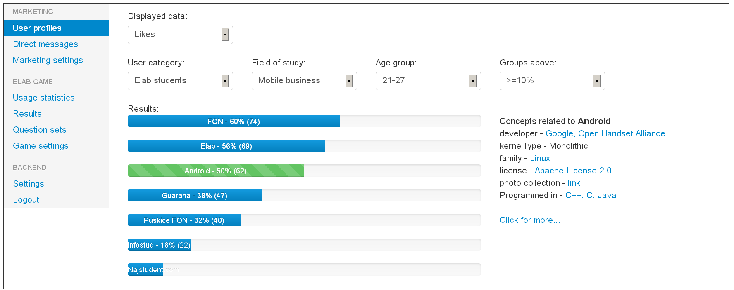

Figure 3. Backend of the application showing the section for review of aggregated user profiles
Statistics that are gathered about the users include their likes, education, and general area of residence (e.g. city or a geographical region). This data is presented in the form of several bars showing concepts most commonly appearing on users profiles. The marketer can select which group of concepts he wishes to display. If, for instance, users are grouped by their likes, the bars will display names of most commonly liked concepts on the bars, along with the percentage of users and their absolute number (shown in Figure 3). The data set can be narrowed using the available filters: user category, field of study, age group, and percentage of appearance among users.
The most important filter is the “user category” filter that contains two categories – users confirmed as E-business Lab’s students and other users. Both categories are of interest – having a profile of the E-business Lab’s students can be used to adjust learning materials and services offered by E-business Lab to better accommodate existing students. It can also be used to extrapolate the profiles of potential future students, since they would likely have profiles to an extent similar to the existing users. The “others” category can give a more direct insight into the types of individuals interested in courses offered by E-business Lab, with the downside being that this category might contain a far more wide demographic. This is where the other filters are useful. The results can be filtered by the field of study that the users selected when starting the game, by the age group (especially important for pinpointing potential students), and only top result groups can be shown, thereby eliminating those that appear only a few times.
When analyzing most common likes, there is a possibility that the marketer will not properly understand the significance of underlying trends, hidden behind their manifestation in the form of likes. For this reason, an option of enriching available concepts using DBpedia was added – the marketer can select any of the presented bars and the relations of corresponding liked term will be displayed on the right side, along with links that offer more information.
The previous steps provide a foundation for an Internet marketing campaign. A good online strategy can provide superior results and can be a lot more successful than traditional forms of marketing. Analysis and selection of the most relevant target audience for ad placement and demographic segmentation were performed for E-business Lab’s campaign. Using the generated profiles, ads need to be placed through the mechanisms available in the social network from which the data was gathered. Activities of projecting an optimal number of ads, defining the advertising structure, and scheduling optimal budget need to be performed. For Facebook ads it is important that their design must have clear and understandable content, and be interesting to potential users in order to pull them in and make them click on the ad. The image has 100x100 pixels and has to be attractive enough for users to wish to read advertisement. When the potential user clicks on the Facebook ad it leads to the landing page shown in Figure 4a). Part of campaign is creating the special "tabs" or sub-pages on Facebook that are located in the top right corner of the page, right under the "cover" image. The role of these tabs is to provide information to the incoming users, and it is the first page that they will see when they click on one of the ads that were placed to the targeted population. Example page and tabs that are created can be seen in Figure 4b). Facebook page of E-business Lab is also improved by following the user's profile and adjusting it to their interests.
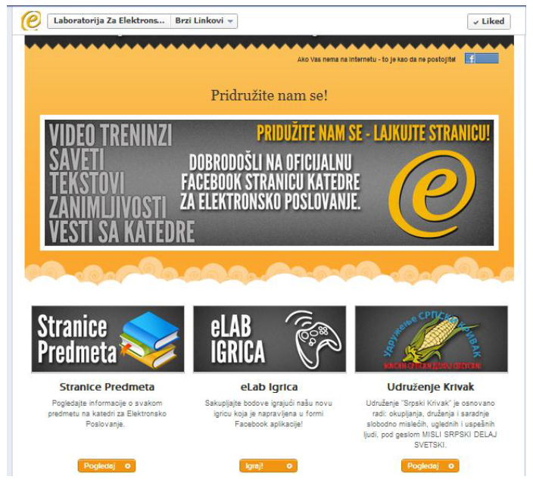

Figure 4. a) E-business Lab's landing page b) Facebook page of E-business Lab
4. Conclusion
This paper provides a description of a model for execution of Internet marketing campaigns via social networks and Facebook in particular. The model requires that a useful social networking application already exists in order to use it as a source for gathering data from consenting users and construct generic profiles of target groups. The entire model was implemented in an educational context, for marketing educational courses to potential students through an educational game. This is a perspective for performing successful business and it allows an organization to follow trends, which is exceedingly important in today’s market. The power of social marketing is huge and the opportunities for both future research and commercialization are endless. Some potential directions for improvement of the presented model are expansion to other social networks besides Facebook and construction of richer profiles, with more detailed presentation of relations between measured data. Semantic web can also be better utilized and a model of more thorough integration of data gathering with the inner working of the base application (e.g. educational game) should be defined. Privacy concerns should also be addressed in more detail in future works.

Literature
1. Kim W., Jeong O.R. & Lee S.W. On Social Web Sites. Information Systems. Vol.35. No.2. 2010. P.215-236.
2. Lehtimäki T., Salo J., Hiltula H. & Lankine M. Harnessing Web 2.0 for Business to Business Marketing- Literature Review and an Empirical Perspective from Finland. Faculty of Economics and Business Administration, University of Oulu Working Papers, No.29. 2009.
3. Thackeray R., Neiger B.L., Hanson C.L. & Mckenzie J.F. Enhancing Promotional Strategies within Social Marketing Programs: Use of Web 2.0 Social Media. Health Promotion Practice. Vol.9. No.4. 2008. P.338-343.
4. Dabbagh N. & Reo R. Back to the future: Tracing the Roots and Learning Affordances of Social Software. Web 2.0-Based E-Learning: Applying Social Informatics for Tertiary Teaching. Hershey, PA: IGI Global. 2010. P.1-20.
5. Kaplan A.M. & Haenlein M. Users of the World, Unite! The Challenges and Opportunites of Social Media. Business Horizons, Vol.53. No.1. 2010. P.59-68.
6. Constantinides E. & Fountain S.J. Web 2.0: Conceptual Foundations and Marketing Issues. Journal of Direct, Data and Digital Marketing Practice. Vol.9. No.3. 2008. P.231-244.
7. Boyd D.M. & Ellison N.B. Social Network Sites: Definition, History, and Scholarship. Journal of Computer-Mediated Communication. Vol.13. No.1. 2007. P.210-230.
8. Westland, J.C. Critical Mass and Willingness to Pay for Social Networks. Electronic Commerce Research and Applications. Vol.9. No.1. 2010. P.6-19.
9. Hellmann S., Stadler C. & Lehmann J. DBpedia Live Extraction. On the Move to Meaningful Internet Systems: OTM. 2009. P.1209-1223.
10. B. Radenković, M. Despotović-Zrakić, A. Labus, M. Vulić, Marketing of Educational Institution on Social Networks. International Scientific Conference: Digitalisation of Cultural and Scientific Heritage, University Repositories and Distance Learning, Proceedings of abstracts. 30 September – 02. October 2011.
11. A. Labus, K. Simić, M. Vulić, M. Despotović-Zrakić, Z. Bogdanović, An Application of Social Media in eLearning 2.0. 25th Bled eConference eDependability: Reliable and Trustworthy eStructures, eProcesses, eOperations and eServices for the Future, 17-20 Jun 2012. Bled. Slovenia. P.557-572.

