ПРИМЕНА ГЕОГРАФСКИХ ИНФОРМАЦИОНИХ СИСТЕМА У КОНТРОЛИ ЗАГАЂИВАЊА ЗЕМЉИШТА ОПШТИНЕ ВРБАС

APPLICATION OF GEOGRAPHIC INFORMATION SYSTEM FOR CONTROLLING THE SOIL POLLUTION IN THE MUNICIPALITY VRBAS

др Татјана Ђекић, доцент, Универзитет у Нишу, Природно математички факултет, Департман за географију
Проф. др Иван Филиповић, ред. проф., Универзитет у Нишу, Природно математички факултет, Департман за географију

dr Tatjana Djekić, assistant professor, University in Niš, Faculty of Natural-mathematic sciences, Department for Geography
dr Ivan Filipović, full professor, University in Niš, Faculty of Natural-mathematic sciences, Department for Geography

Апстракт: У овом раду су приказане могућности примене ГИС-а у управљању заштитом животне средине на нивоу општине, на примеру општине Врбас. На нивоу поменуте општине, извршено је моделовање појединачних елемената животне средине, где је приказано стање природних елемената и приказано је стање после загађивања. Предмет рада је општина у Војводини, Врбас. Задатак овог рада је примена ГИС-а у поступку одређивања стања животне средине, а главни циљ је да се покаже могућност управљања природним елементима путем географских информационих система. За потребе рада, коришћен је програм ArcGIS.

Кључне речи: ГИС, управљање, животна средина, Врбас.

Abstract: The paper presents possibilities of application of GIS systems for governing in environment protection within a municipality using the municipality Vrbas in Vojvodina, as the example. In mentioned municipality was performed modeling for distinct environmental elements, and their natural values are presented along with values after pollution. The main task of this paper is application of GIS technologies for determination of environmental conditions, while the main aim is to point on possible governing over natural elements through these technologies. In this paper was used the ArcGIS Program.
Key words: GIS, governing, environment, Vrbas.

INTRODUCTION

The Geographical Information System (GIS) provides possibility for changes within geographic area to be predicted. Ratios between various environmental elements should be considered over different models. Overall ecological problems are incorporated in GIS, along with geospatial elements and environmental components including natural, society and capital resources. Data related to air, soil, waters, climate, elements of living and non living things, biocenosis, human beings, objects built by human beings (capital resources) etc. are lodged in.
The municipality Vrbas is one of twelve municipalities in the South Bački District. It is bordered with municipalities Kula, Mali Idjoš, Srbobran, Temerin, Novi Sad, Bački Petrovac, Bačka Palanka and Odžaci. The municipality Vrbas covers area of 356.58 km².
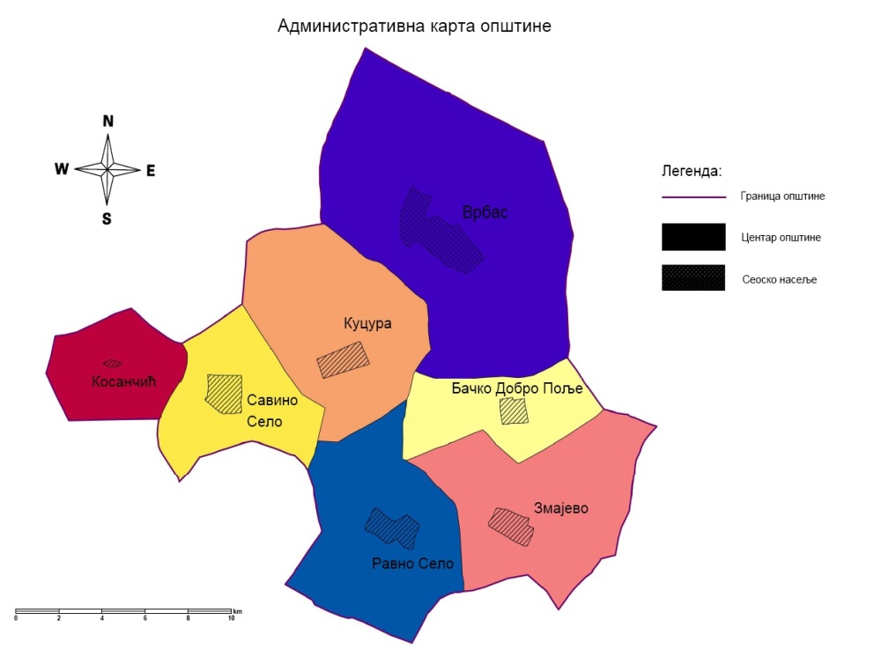
Fig. 1. Map of settlements in the municipality Vrbas (Author: Djekić T., 2013)
According to data of the last official census of inhabitants, held in 2012, the population in the municipality is 45852. The average population density is 129 per km². The municipality consists of 7 settlements.

Table 1. General data on the municipality Vrbas
No | settlement | area (km²) | population | population density per km²
1. | Bačko Dobro Polje | 26.83 | 3929 | 146
2. | Vrbas | 111.74 | 25907 | 232
3. | Zmajevo | 54.24 | 4361 | 80
4. | Kosančić | 23.72 | 163 | 7
5. | Kucura | 54.48 | 4663 | 86
6. | Ravno Selo | 52.18 | 3478 | 67
7. | Savino Selo | 33.41 | 3351 | 100

Territory of the municipality Vrbas is completely flattened as well as in other municipalities in the Autonomous Province Vojvodina. The highest point is at elevation of approximately 104 m a.s.l in Vrbas and the lowest is in its southeastern part, at the place where the channel Jegrička leaves out the municipality, in the village Zmajevo. In the territory of the municipality Vrbas is only 6 water flows. Their importance is negligible.
On contrary, through its territory pass even 159 channels. The most important are the channel Dunav -Tisa – Dunav (the longest channel in our country) and the Great Channel (Veliki Kanal). Channels are of considerable importance, not only for this but for all municipalities based on agriculture. There are also 5 small, artificial lakes rich in fish, as well as 24 marshes.

GIS ANALYSES OF SOIL POLLUTION IN THE MUNICIPALITY VRBAS
The largest area is covered by loess sediments (38.5 % of total municipal area). Geological composition is the consequence of the Pannonia Sea, which existed here. Clays represent, if they are pure, very useful industrial resource. On contrary, for civil engineers, they represent unsuitable ground for building, as they are impermeable. Carrying capacity of clays is extraordinary low; actually these rocks suffer only minimal weights. Before construction, clayey soils need to be electrochemically consolidated.
The most widespread soil in the municipality Vrbas is meadow peat soil with approximately 67% in abundance. Chernozem is high quality soil for nursery of diverse agricultural plants and is characterized by very quality humus layer. It could be inferred that the soil in the municipality Vrbas is of extraordinary quality for agriculture, and is appropriate use for it.
On the other side, extensive use of pesticides and other chemical compounds led to soil damage and synchronously to environmental damages.
Total area covered by vegetation is 7.5 km² what is 2.1% of the municipal territory. Such vegetation is quite reasonable taking into consideration the fact that the economy is based almost completely on agriculture. Soil pollution takes part when superficial horizons are imposed to big masses of waste that could not disintegrate under common atmospheric conditions through self-cleaning.

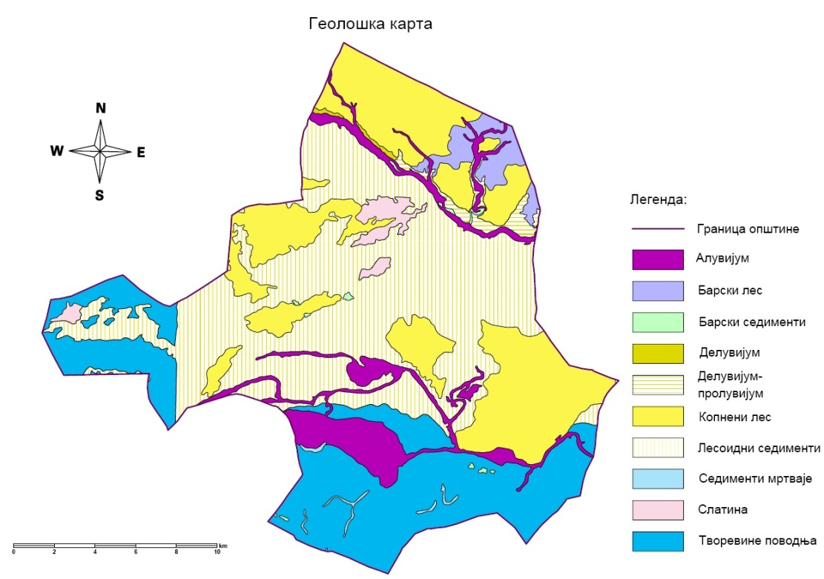
Fig. 2. Geological map of the municipality Vrbas (Author: Djekić T., 2013)

Development of cities with high population, the increase of standard and spent, accompanied with development of industry, more intensive traffic and intense agriculture lead to significant pollution of environment and the soil. Enormous pollution of soil by organic and inorganic compounds destroys the balance in ecosystem and disturbs common processes in soil, leading to its degradation.
Organic matters that are soil pollutants include fecal waste, food waste, waste from food industry, industry of wood and cellulose, petroleum and its derivates, oil and oil slick.
Inorganic matter pollutes superficial, rarely deeper horizons of soil. This happens when polluted waste waters flow-out, when solid waste is accumulated (waste with more or less soluble chemical compounds, disposable bags with rest of contents, batteries, metals and nonmetals from production, waste from power plants). All inorganic either elements or compounds have influence on soil composition and deserve negative impact on environment when pollution reaches certain degree.
Dominant soil pollutant in the municipality Vrbas are:
- City dump;
- Illegal dumps (discarded waste);
- Farms;
- Traffic;
- Main bus station;
- Main railway station;
- Sugar factory;
- Industry of meat and meat products;
- Oil factories;
- Plastic recycling factory.

Beside these pollutants, agriculture additionally contributes to soil pollution.
Use of artificial and mineral fertilizers in order to obtain a higher production of distinct plant species led to changes in soil properties, particularly microbiological. Mineral and artificial fertilizers contain high amounts of nitrogen, phosphorous and potassium. They are commonly produced as salts required for plant growth. Chemically, they are most frequently nitrates and sulfates. As are soluble, such compounds pollute soil and afterwards leach and damage ground waters along with surface waters. Plants use only a part of these compounds. The remained part is leaching and either sink into depth or be absorbed at surface turning into more stabile compounds, which change chemical composition of soil. The final effect is change of soil acidity (pH) and microbiological properties. Precise data of fertilizer in the municipality Vrbas are lacking.

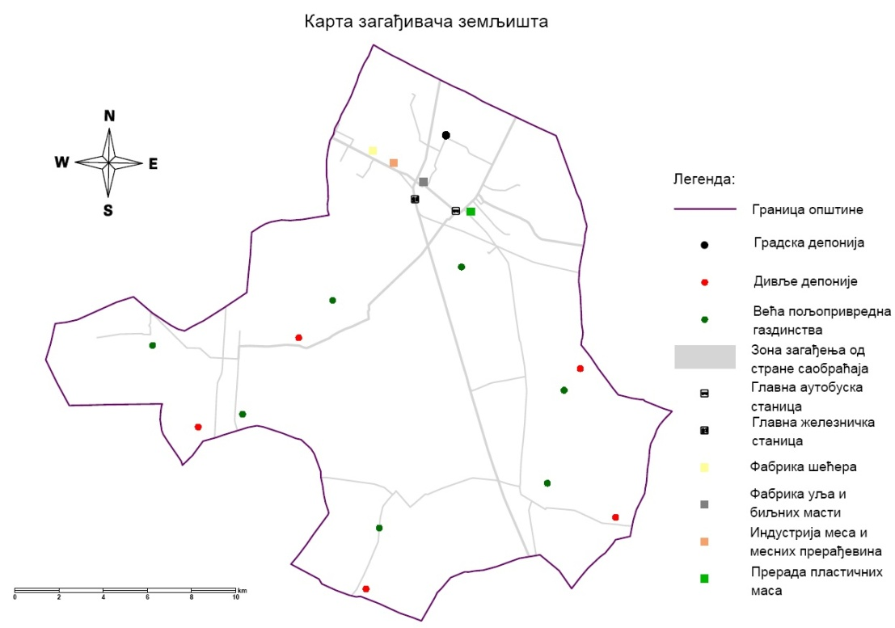
Fig. 3. Application of GIS in recognition of soil pollutants in the municipality Vrbas (Author: Djekić T., 2013)

According to obtained information data in the territory of Vrbas are in use wide spectrum of domestic and foreign products, as herbicides. Numerous diverse insecticides and fungicides are also in use, but data on their approximate amount are lacking.
Although pesticides are commonly low resistant and decay in soil is pretty fast, their negative impacts are the consequence of their wide use and extensive influence, along with very toxic substances contained in them. Therefore, pesticides may in short period cause drastic changes in soil quality and fertility, and consequently decrease biological potentials. Insecticides, based on metals, act as abdomen poison when comes in organism through mouth, i.e., digestive system. Their acting mechanism is related for bounding of arsenic for sulphur hydrogen groups in enzymes or replacement of phosphorous by adenosine three phosphates. This leads to metabolic changes and coagulation of proteins. These compounds are very toxic, not only for insects whom are dedicate, but for human beings and animals, too. Fungicides are pesticides served for inhibit various parasitic plants. They are used as liquids for sprinkling agricultural products for preventing development of fungi spores and fungi. Organic compounds of mercury, sulphur, formaldehydes and cuprum are the commonest in use. Herbicides may destroy all or distinct plant species. They are commonly used as acids, particularly sodium and sulphuric acid, and oil solutions. They are dangerous for human beings and animals, not only for weed. Although all these compounds are use for higher and more quality agriculture yield, their long use has adverse effects. Pesticides spread their negative impacts from dedicated group to soil affecting other plants and animals. Furthermore matter cycles over either food chain or direct contact with polluted water and air has negative influence on human beings.
Atrazine is herbicide from pesticide group widely used for weed inhibiting. It carries sign XN what means is harmful for health. It is forbidden for use in Serbia since the Republic Direction for plant protection brought decision on December 31th in 2007. The causes for such decision are extremely toxic component in it and polluted ground waters. Although the situation is not so alarming, its further use could make it very soon.
Organic compounds of mercury are liposoluble (oil-soluble) compounds and because of it posses high accumulative ability (in milky glands making babies particularly vulnerable and exposed to risk). They tend to accumulate in brain tissue, liver and kidneys.
Heavy mercury poisoning includes symptoms like: weakness of legs and arms, total muscle weakness, reduced visibility and damaged sense of hearing and speaking. In extreme cases come madness, paralysis, coma and death. Formaldehyde brought in organism oxidizes and turns to formic acid that decrease the pH values in blood (with increasing acidity), even can be deadly. Formaldehyde is toxic and carcinogenic compound and may cause asthma.

POLLUTANTS IN SOIL THAT MAY BE PRESENTED BY GIS

Various industrial products pollute soil: either over vapor phases released during combustion into the soil or over different waste materials. Heavy metals when enter once in soil practically remain in it evenly as are not decomposable like other contaminants.
Traffic as soil pollutant. Emissions from vehicles consist of several hundred compounds. Considerable components – pollutants include either liquid or solid particles, carbon monoxide, carbon dioxide, nitrogen and sulphur oxides and carbon hydroxides that are signed all together as vaporous organic compounds. Emissions from vehicles also includes resistant compounds that may retain in environment for many years, alike heavy metals (led, cadmium, poliaromatic carbon hydroxides and chlorine). Sulphur and nitrogen compounds contribute in formation of acid rains and soil desiccation.
The use of soil as traffic route is additional problem as disable soil to be used for other purposes (e.g. in agriculture). Unfortunately the constant growing of cities requires more extensive traffic routes, what has adverse effect on environment.
Illegal and city dumps. All waste from the territory of the municipality Vrbas is left on city dump, distant from the center of the city only a few kilometers. Inadequate discard of waste on unhygienic dumps causes soil and ground water pollutions. Precipitations that percolate through mass of wasting material dissolve dangerous matter and pollute soil and ground waters. Additional problem is that soil pollution affects wider area, not only locally, and damage flora and fauna on and in the ground. Furthermore problem is soil pollution caused by waste particles carried by wind. Percolating waters from dumps harms ground and surface waters and soil due to high content of organic matter and heavy metals.

SOIL POLLUTION CONTROL IN THE MUNICIPALITY VRBAS USING GIS

In agriculture – Soil analyses and appropriate education of agriculturalists. Soil analyses provide with information about proper fertilizer concerning type, amount and period of its application. This mere leads to significant rationalization of fertilizer use in respect to, unfortunately fertilizer use without previous analyses at us. The main task of agricultural experts and agricultural scientists it to achieve high and stable yields of good quality through minimal investment of material, energy and effort. That should be done following rules for maximal efficiency accompanied with protection of environment, agro ecosystem and overall biosphere from injurious impacts and pollutions.

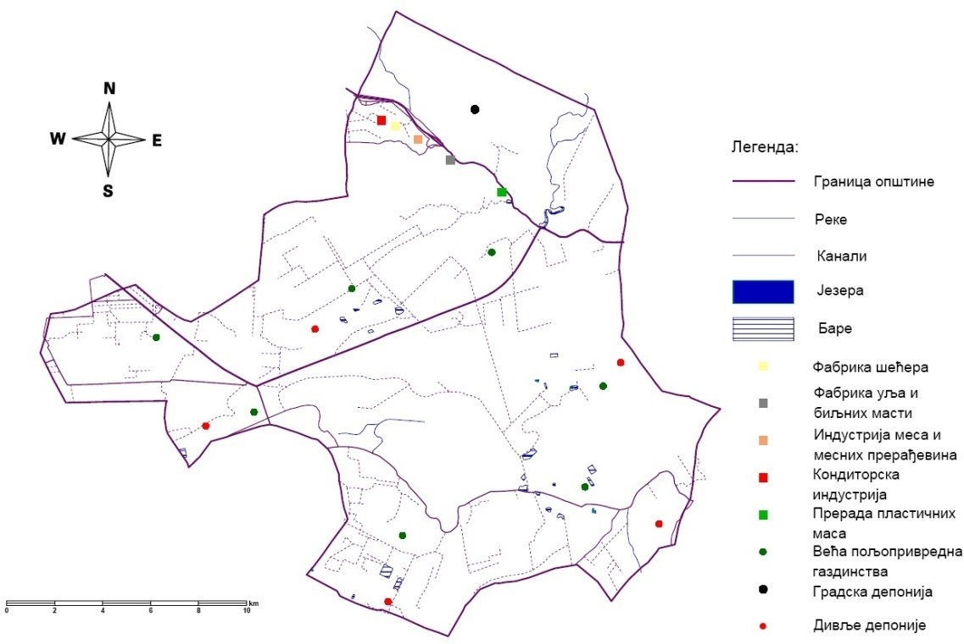
Fig. 4. Soil pollution control in the municipality Vrbas using GIS (Author: Djekić T., 2013)

In the field of waste disposal – establishing a plan of waste disposal; define conditions for joining to regional dump; expanding of territory for dump discard on all local communities.
The biggest role in soil pollution has man with his activities. Pollutants of surface and ground waters in the municipality Vrbas are:
- Settlements;
- Industrial objects;
- Agricultural farms;
- Illegal dumps (discarded waste);
- City dump;
- Chemical adding to soil (pesticides and nitrogen fertilizers).
Waste waters are commonest worthless matters that discharge like liquid, suspension or colloid solutions from settlements and industrial objects. They could be divided in three groups:
- waste waters from settlements derived from human beings and animals;
- industrial waste waters;
- atmospheric waters.

CONCLUSION

The quality control of soil pollutants in the municipality Vrbas requires application of GIS technologies from following reasons:
- limited capacities in natural environment;
- high rate of environmental pollution;
- and need for complex ecological problems to be solved.
Complementary part of GIS is establishing of data base and afterwards a cadastre of sources of environmental pollution and integral preventing. A cadastre of sources of environmental pollution represents the initial form for environmental monitoring. Monitoring system includes three main procedures:
- observation and control
- prognosis or attempt to predict possible changes in nature under influence of natural or anthropogenic factors
- regulative measures of environmental conditions and governing within it.
Monitoring needs to include all developing resources in the municipality Vrbas.
References
- Borough P. A., McDonnell R. A. (2006): Principi geografskih informacionih sistema, Prevod sa Engleskog jezika (Bajat B., Blagojević D.), Građevinski fakultet, Univerzitet u Beogradu, Beograd.
- Кукрика М. (2000): Географски Информациони Системи, Универзитет у Београду, Географски факултет, Београд.
- Љешевић М. (2005): Животна средина, Универзитет у Београду, Географски факултет, Београд.
- Љешевић М., Милановић М. (2004): Улога информационих система у истраживању и заштити животне средине, Зборник радова LI, Географски факултет, Београд.
- Lovett A., Appleton K. (2008): GIS for Environmental Decision – Making, CRC Press, Boca Raton, London, New York.
- Marković, J. Đ. (1980): Regionalna geografija SFR Jugoslavije, Građevinska knjiga, Beograd.
- Милановић М., Ђекић Т. (2003): Поступак генерализације садржаја мапа и планова путем ГИС алата, Зборник радова са скупа планска и нормативна заштита простора и животне средине, Географски факултет Универзитета у Београду–Институт за просторно планирање, Асосцијација просторних планера Србије, Палић.

