УДК 904

Yu.V. Shirin
Novokuznetsk institute (branch) Kemerovo state university (Russian Federation)
ANCIENT STONE SCULPTURES OF NORTH-WEST MONGOLIA
AND ATTITUDE TO THEM NOW

The article deals with information on stone statues that were investigated in several areas in Uvs aimag, in a vicinity of the lake Uureg. In addition to those known for a long time, new objects have been identified including deer stones. Surveyed monuments has localized and mapped sites by GPS. Many monuments are damaged. Some of ancient stone statues are visited by prayers (mostly by Derbets) along with modern cult constructions as obos and inders. Tradition establishes several special reasons for prayers and offerings to the certain statues. We have noted the use in cult purposes of some stelae into enclosures and some khirigsuurs. Taking into account information on a modern use of ancient monuments, it is necessary to make efforts for ensuring a maximum preservation of their original appearance.
Keywords: Uvs aimag, Derbets, stone statues, deer stones

Приведена информация об объектах, которые были исследованы в нескольких районах Увс аймака, в окрестностях озера Урэгнур. Кроме уже известных выявлены новые статуи, в том числе и оленые камни. Даны географические координаты обследованных памятников по GPS. Многие памятники повреждены. Некоторые из древних каменных статуй посещаются молящимися (в основном дербетами) наряду с современными культовыми сооружениями, такими как обо и индеры. Традиция устанавливает несколько особых причин для молитв и приношений к определенным статуям. Также отмечено использование в современных обрядах одиночных стел в оградках и некоторых херексуров. С учётом информации о современном использовании древних памятников, необходимо приложить усилия для обеспечения максимального сохранения их первоначального вида.
Ключевые слова: Увс аймак, дербеты, каменные статуи, оленные камни

Russian-Mongolian expeditions of Kemerovo state university and of the Ulaangom local museum have recorded archaeological sites of North-West Mongolia in Uvs aimag in 2011–2012. Studies have been done in a vicinity of the lake Uureg and in valleys of rivers Bargustai, Hondlon-gol, Tarialan. More than 200 ancient objects, such as rock engravings, khirigsuurs, stone enclosures, stelae, stone statues, were descriptioned (Kimeev et al., 2012: 36–51). Several previously unknown Paleolithic sites and stone sculptures have been found.
Among numerous ancient sites of Mongolia, stone sculptures deserved special attention. They were erected at different times, from the Bronze Age to the Middle Ages. Information about stone statues of Uvs aimag, containing in publications (Ser-Odzhav, 1970; 1984; Khudyakov, Plotnikov, 1990; Bayar, 1997: 83–99), was compiled in one scroll by Byambadorzh T. There are 102 stone statues besides of stelae and deer stones (Byambadorzh, 1999: 34–36; 176–179). Shortcomings of this scroll are a limited information and a weak address binding of objects. It makes difficult to identify of statues. We managed to examine some of monuments from this scroll only thanks to the help of Lhagvasuren B. of the director of the Ulaangom local museum. He has already done a lot of work to identify ancient sites on the territory of Uvs aimag before our work began. Lhagvasuren B. has given detailed descriptions of identified statues, has photographed in various degrees of detail, has localized and mapped sites by GPS.
The article presents information on some stone statues examined by the expedition. Some of them were already known, but additional information was collected. Statues, which we saw at museums of some district centers of Uvs aimag (Kimeev et al., 2012: col. ins. XIII), was not considered here.
Ancient Turkic stone statues in a valley of Bargustay river, south of the lake Uureg, are known for a long time. These statues have been badly damaged. Monitoring of a status of these sites presents some interest, since they are standing near one of transit routes of the region.
The coordinates of one of the objects are N 50º00.220', E 91º02.709'. That are three rectangular enclosures along the line N–S with two circular constructions (about 1.5 m in diameter) in the end (Kimeev et al. 2012: col. ins. VI). The northern enclosure is 3.8x3.8 m. That construction is shifted to the north-east relative to the axis of the middle and the southern enclosures. A pebble stele is at 1.6 m to east from the eastern wall. The middle enclosure is 3.8x3.6 m. A stone statue is at the eastern wall outside. The statue rises to 65 cm. The top of a rounded head was broken. On the face we can see a right eye, a nose, plump lips and a mustache with curled up pointed ends. A torso is buried till a belt. The relief on the torso has exfoliated off. A row of four stones through 3.8, 5.5, 8.4, 11 m are setting on the east of the statue. The southern enclosure is 4.2x4.2 m. A stone statue is at 65 cm to east from the middle of the eastern wall. The statue rises to 85 cm. The right part of the head is broken. Next to the statue, slightly to the north, a short stele sticks out. At 5 m to east from the statue is a stone. On the statue's face the left eye, a nose and a bent-up tip of a mustache are shown by a relief. A pointed chin and a triangular neckline of a dressing gown are shown by one in-depth line. The right arm is bent on the chest at the elbow, holds a jug with a ring base and a neck conical. The left hand is lying on a hilt of a sword above a belt. Rectangular overlays of the belt with cutouts are shown by a relief. A dagger with a cranked handle and two ledges on a scabbard is shown hanging on the belt in the center of the figure. An oval handbag with a closed valve is shown on the belt on the right side.
The coordinates of the object are N 50º00.489', E 91º02.932'. That are three enclosures along the line N-S with statues on east sides of them. The northern enclosure is 2.7x2.5 m. A stone statue having a broken head is outside near of the middle of its eastern wall. It is buried to a waist. The fragment rises to 45 cm. A relief on a torso is rough. The right arm bent at the elbow is visible on the chest. A cup is standing on its palm. The left hand is lying on a belt.
The middle enclosure is 2.8x2.7 m. Outside of the middle of the eastern wall, a stone statue is standing. Its head is broken to eyebrows. It is buried to the middle of thighs. The statue rises to above 90 cm. On a round face arched eyebrows, oval eyes, a nose widening downwards, lips and a mustache with pointed tips are shown by a relief. On the chest a triangular neckline of a dressing gown is shown. Reliefs of the right arm and a jug have exfoliated off totally. A belt is visible only on the left side. Rectangular overlays of the belt with cutouts are shown by a relief. The left hand brush is visible above the belt.
A small round stone paving is between the middle and the southern enclosures. The southern enclosure is 2.8х2.7 m. A stone statue with a broken head is outside of the middle of the eastern wall. It is buried to the waist. The fragment rises to 45 cm. The right arm is bent on the chest at the elbow, holds a jug with a ring base and a neck conical. The left hand is lying on a hilt of a sword above a belt. Rectangular overlays of the belt are shown by a relief.
Another stone enclosure 3.8х3.8 m was found at a distance from those complexes. The coordinates of that site are N 50º00.397', E 91º02.965' (fig. 1/ 1). A stone paving 1x0.9 m is outside on the middle part of the north wall. A chain of vertically buried and lying stones are running from the middle part of the eastern wall of the enclosure to south-east (azimuth from the center of the enclosure is 125 degrees). The stones were fixed at intervals of 4, 3, 4, 8, 6, 6, 7, 6, 13, 8, 8, 11 m. Two fragments of a stone statue were found in 0.5 m to the east from the south-east corner of that enclosure (fig. 1/ 2). A fragment of the upper part of the statue lay face down. A fragment of the lower part lay on the back surface and almost entirely was covered by ground. The fragments of the discovered statue were extracted for measurement, photographic and drawing.
The fragments have approached each to other well (fig. 1/ 3). The total length of the docked fragments is 90 cm; the maximum width of the statue is 33 cm; the thickness of the block is not less than 15 cm. The top fragment is a lower part of a broken round head with an upper part of a torso with narrow shoulders. The fragment of the head has a horizontal line of closed lips and a rounded chin. A relief bowl with a ring base supported by fingers of the right hand is on the breast. Another fragment is a lower part of the figure, broken off just below a belt. A relief buckle and massive rectangular overlays of the belt without small details are on a waist. The right arm, bent at the elbow, is above the belt. The left hand is on a handle sticking above the belt. Probably, that is the handle of a saber, but there is no continuation of it below the belt. An oval handbag with a closed valve is shown on the belt on the right side. A dagger with a cranked handle and two ledges on a scabbard is shown hanging on the belt in the center of the figure. Other debris of the statue has not been found among stones of that enclosure.
In the Mongolian Republic it is not recommended to export to museum storehouses not only sculptures but fragments as well. They must remain in their original place and in a historically developed form. Any improvement of the external appearance of a monument, such as the alignment of inclined statues and stelae, digging out buried ones is not recommended. Therefore, fragments of the statue have been put into original places after examination.
Three enclosures 3x3 m with two broken stone statues and a stele are in Khara tolgoy area, to south-east of the lake Uureg. The coordinates of that site are N 50º02.177', E 91º09.588'. Both the stone statues are broken to three parts. Details of a relief of statues on surviving fragments are not easily discernible. One of the statues, made of red sandstone, had preserved better. If a head and two fragments of a torso will be united, the height of the statue is 90 cm. Relief arched eyebrows, almond-shaped eyes, round cheeks, a straight nose and mustaches with twisted up tips are on an oval face. On a breast of the statue a bowl is shown in the right hand. The left hand lies on a poorly visible belt with suspended equipment (Kimeev et al., 2012: col. ins. XIII).
Stone statues are at several sites of a valley of Hondlon-gol river, on its left bank. The largest statue is downstream from a former district center Delgermuren. The coordinates of that site are N 49º57.120', E 91º23.190'. The sculpture is made of a block of sandstone of oval cross-section 37 cm wide. It raises to 1.15 m. Arched eyebrows, a straight nose, almond-shaped eyes and thin lips are shown by a relief on an oval face. There are shown earrings with round pendants. On a chest of the statue is shown the right hand bent at the elbow supported a bowl by fingers. The left hand lies on a belt. The sculpture is buried to the belt so its details are not clear. An area around of the sculpture about 4–5 m in diameter has been contoured by stones, with a rupture in front of the sculpture face (Kimeev et al., 2012: col. ins. XVI). This entourage has taken a shape recently. Derbets are performing rituals before horse racing here. They have left various offerings near the statue, mostly money, and have tied buddhies khatas to a neck of the statue. The statue is fed abundantly, judging by the fatty stains on its chest and face. There are no ancient stone enclosures near this statue. Perhaps, the statue was transferred to a modern ritual place.
A khirigsuur — a round mound about of 1 m high and of 16 m in diameter in a center of a stone fence of 54 m in diameter is at the coordinates of N 49º57.234', E 91º23.136'. The eastern sector of the circle has been destroyed by channels of seasonal flows. Five strips of radial stone lines made through 15º have been remained only in the north-western sector inside of the ring. A second round mound of 6.4 m diameter is into the southern sector of the circle. A deer stone of the Eurasian type from a granite boulder 80х35х30 cm is stand on the central mound of the khirigsuur, in its north-western part. The top part of the deer stone is distinguished by a horizontal necklace of round holes connected at the back of the stone by a ring of the larger diameter than the holes. There are three oblique lines on the front side, and earrings on the sides (Kimeev et al., 2012: col. ins. X). The deer stone rising to 70 cm was fixed on the top of the mound vertically recently. It is supported by large boulders. The front side of the stone with oblique lines is deployed from the center of the mound to the north-east. A scull and other bones of a sheep are visible to south-west from the deer stone under stones in a failure on the top of the mound. Those bones are laid there by Derbets.
A second deer stone was found near of a stadium of the former district center of Delgermuren. The coordinates of that site are N 49º55.168', E 91º23.493'. A chain of 6 enclosures of different sizes are stretched on 25 m from south-east to north-west. Corners of enclosures are oriented to the sides of the world. Stelae and boulders are in front of faces the north-east walls of the enclosures. The broken deer stone from a bar of a stone of a rectangular cross section 27x35 cm is outside the north enclosure 4.5х4 m. The slough is fresh. The broken stone lies near of own buried base. If the broken fragment will be combined with the base, the rising of the deer stone is 1.2 m. It is the Eurasian type. The top part is marked with a horizontal necklace of round holes. Three slashes were knocked out in a place of a face and earrings on the sides. On the right side, at a level of a belt, there is a hatchet and on the left side there is a gorytos. On the broken front of the deer stone there is a sloping strip.
Another chain of 4 of pebbles squares is near of those enclosures. The coordinates of that site are N 49º55.122', E 91º23.443'. A length of the object from south to north is 15.5 m. A stone statue from a block of gray slate up to 50 cm wide and 25–30 cm thick is at the eastern side of northern square (4x4 m). There are stelae on the eastern sides of other squares. The stone statue is buried below a belt, rises less than 1 m. It inclines slightly to the left shoulder. The right side of a torso is broken down. Relief arched eyebrows, straight nose, almond-shaped eyes, thin mustaches with sharp pointed tips, a lower lip are shown on a broad face of a round head. The face of the sculpture is impregnated with a fat due to rituals that being held regularly by Derbets.
A statue is on the site with the coordinates of N 49º57.280', E 91º23.202'. It is deeply buried and overturned backward. Only a head and shoulders are visible out of an earth, to a height of less than 40 cm. The figure is faced to north-east. An oval face of the statue is badly damaged. Relief details are almost lost, but earrings with a drop-shaped pendant are visible. On the top of the head there is a pineal hairdo.
A stone enclosure 3.5х3.5 m is in Bumbatyn aman area, on the right bank of Hondlon-goal river, upstream from ruins of the monastery Togs Buyantyn tuur. The coordinates are N 49º54.039', E 91º22.494'. A stone sculpture from a gray slate is deeply buried at the eastern wall of this enclosure. The face of the sculpture on a rounded flat head is worked out extremely schematically. The statue is tilted to the left side. The head and the right shoulder with the right arm bent at the elbow are visible only. The shape of a vessel in the hand is not clear. The sculpture rises to 35 cm (Kimeev et al., 2012: col. ins. XIII).
Conditions in which some of ancient stone statues have been damaged and broken are different. Objects near busy routes are suffering the most. But a local population has the opinion that statues are struck by a lightning.
Some of ancient stone statues are visited by prayers (mostly by Derbets) along with modern cult constructions as obos and inders. This indicate fat spots from the «feeding» on heads of stone figures and on offerings in a form of money, of bowls with drinks installed near of a base, of fabrics tied to statues. We have noted the use in cult purposes of some stelae into enclosures. Skulls of sacred animals are tied to them (Kimeev et al., 2012: col. ins. VII; XLII), and the bones are buried often under stones inside of enclosures. However, on a question about bones recently laid under stones of ancient sites, Derbets can evasively to respond: «Any wolf did it perhaps». Tradition establishes several special reasons for prayers and offerings to the certain statues. For example, offerings for the statue named Tsagaan Hosho (Kimeev et al., 2012: col. ins. XVI), on the northern outskirts of Uulangom, perform during the celebration of Tsagaan tsar — Mongolian New Year. On this statue hadaks are tied and near of feet money and figures of horses (children's toys) are laid. The stone statues in the valley of Hondlon-gol river are reverenced specially during the celebration of Naadam. It is the traditional holiday ceremony, one of the most popular festivals in Mongolia, which is held throughout the country during the midsummer. These days, sports competitions on a wrestling, a horse racing and an archery are organized.
Information on a modern use of ancient monuments has to be collected everywhere. It is necessary to make efforts for ensuring a maximum preservation of their original appearance.

Literature:
Bayar D. Turkic stone sculptures of Central Mongolia. — Ulaanbaatar: Institute of History of the Academy of Sciences of Mongolia, 1997. — 148 pg. (In Mongolian)
Byambadorzh T. Memorials of history and culture of Uvs aimak. — Ulaanbaatar, 1999. — 179 pg. (In Mongolian)
Khudyakov Yu.S., Plotnikov Yu.A. Ancient Turkic stone statues in the southern part of the Ubsunur hollow // Archaeological, ethnographic and anthropological studies in Mongolia. — Novosibirsk: Nauka, 1990. — pgs. 111–125. (In Russia)
Kimeev V.M., Terentyev V.I., Akulova A.S., Shirin Yu.V., Lhagvasuren B. Essays on Western Mongolia. — Kemerovo: Primula, 2012. T. 1. Traditions and the Present. — 206 pg. (In Russia)
Ser-Odzhav N. Ancient Türkic (VI-VIII century). — Ulaanbaatar: Publishing house of the Academy of Sciences, 1970. — 116 pg. (In Mongolian)
Ser-Odzhav N. Newly discovered stone sculptures // News of Academy of Sciences. — 1984. — №4. — pgs. 15-24.(In Mongolian)

Fig. 1. Ancient Turkic stone enclosure on the area Bargustai near from the lake Uureg where a ruined stone sculpture was found
1 – location of the site; 2 – the site plan with indicating a place of fragments of the stone sculpture; 3 – the fragments of the stone sculpture
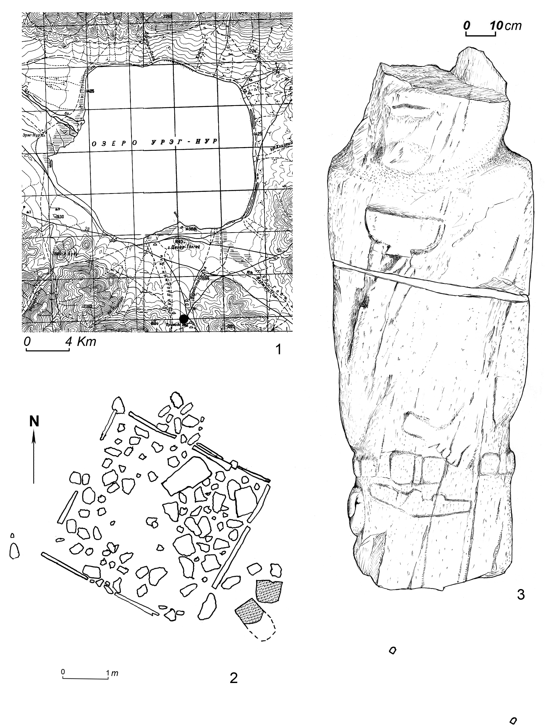

Fig. 1. Ancient Turkic stone enclosure on the area Bargustai near from the lake Uureg where a ruined stone sculpture was found
1 – location of the site; 2 – the site plan with indicating a place of fragments of the stone sculpture; 3 – the fragments of the stone sculpture

