Improvement of the metadata base for the infrastructure of spatial data on glaciers
Aleksandr D. Kitov, Victor M. Plyusnin
V.B. Sochava Institute of Geography SB RAS
kitov@irigs.irk.ru, plyusnin@irigs.irk.ru
A proposed framework of spatial data for the information on the glaciers of Southern Siberia, taking into account the international glaciological database which permits reading metadata and data, reflecting the dynamics of glaciers, the current state, cartographic representation and remote sensing data of these objects.
The existing directories of glaciers do not correspond to the actual representation of data in electronic form. The electronic database (DB) of glaciers in the CIS in format World Glacier Inventory (WGI) [1], integrated into the international database (World Data Center on Glaciology) [2], actually reduplicates the information from paper catalogs of the USSR. Undoubtedly, this first step is necessary and useful, but it requires further development in the sense of spatial data infrastructure (SDI), taking into account contemporary research using remote sensing (RS), development of Internet and geoportals GIS-technologies and GPS-metering.
As is known, the structure of existing database is as follows (20 fields): the code of the glacier, name, latitude, longitude, year of publication of the topographical map, available aerial photography, aerial photography date, total area of the glacier, the accuracy of its determination, the area of the open part, the area of the ablation zone, length, length of the open part, exposition of the accumulation zone, exposition of the ablation zone, the highest point, the average height, the lowest point, the lowest point of the open part, classification [1]. A glacier has a unique index code. Therefore, leaving the main line of the database unchanged by the code, we can bind additional fields (Fig. 1), specifying the characteristics of existing glaciers, or introducing a new line (a new glacier) according to certain rules.
Line of the original database
Code
Attributes
Code

Improved Attributes
Code

References to the graphic objects
Code

Attributes and references of enhancement расширения

Fig. 1. The structure of the database directory of the glaciers

"The line from the original database" (code and characteristics) - is developed in the Institute of Geography RAS under the leadership of Academician V.M. Kotlyakov and transferred to the WGI [1].
"Improved attributes" will more accurately indicate the coordinates of the center of the glacier, the name of the glacier, to clarify some details, or add some values if they were not known at the time when the source directory was worked out. The attributes "References to graphical objects" will show a glacier in geoportal according to the appropriate link, for example, Google Earth (format kml), as well as the current map-type, stage of change over the years, visualizing remote sensing data and other graphical presentations and diagrams.
"Attributes and expansion links" are the results of recent studies that show the current state of the glaciers, the reconstructed data, dynamics and forecasts of nival-glacial geosystems and other.
There are attempts to display information about the glaciers in Google Earth at the present time[3], but they are based on the WGI data, which, unfortunately, contain errors. As exemplified by the label of the glacier 29 in the area of Munch-Sardyk (Eastern Sayan) is displayed on the site of Peretolchin glacier, and the labels of Peretolchin and Radde glaciers are shown further east with the same coordinates, although they are located at a distance of nearly 3 km.
A GIS project by applying the software package ArcView-3.x of the glaciers of southern Siberia from Kodar to the Eastern Sayan, including poorly-studied glaciers Barguzin and Baikal ranges [4]. According to contemporary remote sensing data the coordinates, boundaries, area, and other parameters of the glaciers of these areas are specified. In this regard, we propose the following amendments.
In East Sayan, Munku-Sardyk massif and Peretolchin glacier should be divided into two glaciers: the North (in Russia) and the South (in Mongolia) with the coordinates, (51.722, 100.6) and (51.718, 100.602) respectively. It is necessary to increase the number of decimal places from two to three. New glaciers at the Mongolian side are added Babochka (discovered in 2007) and Pogranichniy (marked on the topographical map, but not recorded in the catalog), with the coordinates (51.736, 100.676) and (51.735, 100.538) respectively. Radde glacier has coordinates (51.743, 100.585), the glacier № 29 (Zhohoysky) does not exist according to recent field studies. As far as the classification of glaciers of Mongolia had the index SU, but the new glaciers (southern Peretolchin, Butterfly and Pogranichniy) receive codes: SU5B16201001, SU5B16201002 and SU5B16201003 respectively. Table 1 shows the initial field of a fragment of the elaborated database.
Table 1
Code | Glacier name | Lat | Long | Topo year | Photo type | Photo year
SU5B16201027 | 27 | 51,80 | 99,47 | -99 | N/A | -99
SU5B16201028 | 28 | 51,97 | 99,53 | -99 | N/A | -99
SU5B16201029 | 29 | 51,72 | 100,60 | -99 | N/A | -99
SU5B16201030 | RADDE | 51,743 | 100,584 | 1962 | QB | 2006
SU5B16201031 | PERETOLCHINA | 51,723 | 100,600 | 1962 | QB | 2006
SU5B16201001 | PERETOLCHINAS | 51,718 | 100,602 | 1962 | QB | 2006
SU5B16201002 | BABOCHKA | 51,737 | 100,575 | -99 | QB | 2006
SU5B16201003 | POGRANICHNIY | 51,737 | 100,538 | 1962 | QB | 2006

In the field «Glacier name» the north Peretolchin glacier is still under the former name and the south one gets its name PeretolchinS. The glaciers number 27, 28, 29 retain the old coordinates, as their additional ground research is still required.
The field «Topo year» - the publication date of a topographical map, of an actual application of a glacier onto the topographic maps, remains unchanged. At the same time, there is a new high-resolution satellite imagery, allowing to identify the boundaries of nival-glacial formations and examine their structure in details. Therefore, in the fields «Photo type» and «Photo year» a satellite and the year of the survey are indicated, Quick Bird of the year 2006 with a resolution of 0.61 meter, in this case (see the Table 1.). The value (-99) means that there are no data.
The fields «Total area, Area accuracy» (see the Table 2 - for the glaciers of Munku-Sardyk) are specified with the year of the survey. Under the general area of the Peretolchin glacier we understand the area of a reconstructed glacier, as under the modern moraines the processes last associated with the melting of buried ice stream. The accuracy of determining the area is calculated taking into account the perimeter of the glacier and the spatial resolution QB (0,6 m). It is believed that line of the glacier perimeter is represented in a pixel. The area is calculated in the projection map, the area of ​​the ice surface is a bit larger.
Table 2 (Continued Table 1 for the glaciers of Munku-Sardyk)
Code | Total area | Area accuracy | Area exposed | Area ablation | Max length | Max length ex | Orientation ac | Orientation ab
SU5B16201030 | 0,1998 (0,3) | 1,3%  (15-25%) | 0,1998 (-99) | 0,1998 (-99) | 0,783 (0,6) | 0,783 (0,6) | 33 | 33
SU5B16201031 | 0,925 (0,7) | 1,9%  (5-10%) | 0,3064 (-99) | 0,3064 (-99) | 1,3 (1,0) | 0,805 (1,0) | 355  (360) | 355  (360)
SU5B16201001 | 0,611  (?) | 1,3%  (5-10%) | 0,151 (?) | 0,151 (?) | 0,681 (?) | 0,53  (?) | 150 | 150
SU5B16201002 | 0,018  (?) | 4,9% | 0,018  (?) | 0,018  (?) | 0,210 (?) | 0,210  (?) | 130 | 130
SU5B16201003 | 0,124  (?) | 1,6% | 0,124  (?) | 0,124  (?) | 0,569 (?) | 0,569  (?) | 123 | 123

Table 2 (continuation)
Code | Max elev | Mean elev | Min elev | Min elev ex | Classification | Area ex1 | Area ex2 | Area ex3
SU5B16201030 | 3198  (?) | 3022 | 2846  (2830) | 2846  (2830) | 640210
SU5B16201031 | 3485  (3490) | 3236,5 | 2988  (2910) | 2988  (2910) | 640210 | 0,819 | 0,476 | 0,306
SU5B16201001 | 3476 (3490) | 3359,5 | 3243  (?) | 3243  (?) | 640210 | 0,587 | 0,342 | 0,151
SU5B16201002 | 2940 | 2900 | 2860 | 2860 | 640210
SU5B16201003 | 3480 | 3240 | 3040 | 3040 | 640210
In parentheses there are the values from the database WGI, where they have changed. The values of (-99) - data are not known for the directory, (?) - no data in the directory.
The fields «Area exposed, Area ablation» (open part of the area and ablation) are defined by modern remote sensing data, and with the help of GPS-symmetry, where possible, and are essentially the same, as in the dirty weather the entire glacier is covered with snow and then melts, without forming the firn line.
The field «Max length» is defined to the edge of a modern terminal moraine, and the length of the open part of the «Max length ex» of the glacier according to the present data.
The fields «Orientation ac, Orientation ab» - the orientation of the relevant parameters is actually saved (the azimuth is indicated from the top of the glacier). The fields «Max elev, Mean elev, Min elev, Min elev ex» - refined based on GPS measurements and digital elevation model (DEM). The field of glacier classification «Classification» is saved.
In the fields «Area ex1, Area ex2, Area ex3» the area of Peretolchin glacier 100 years ago 50 years ago and the modern state is shown, it is possible to follow the dynamics of area changes, according to its northern and southern parts (Fig. 2). The area in the early twentieth century is reconstructed (Fig. 3) according to the analysis of ground photographs, satellite images and diagrams by Peretolchin (Fig. 4). Satellite images and photographs (current and made by Peretolchin) provide a more accurate projection of the primary circuit in the modern topographic map.

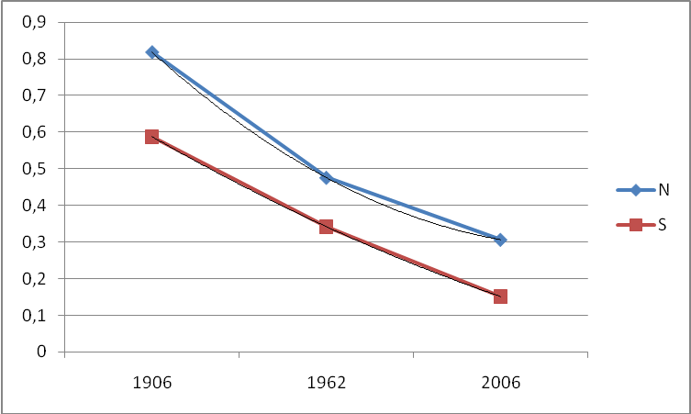
Fig. 2. Changes in the open area of ​​the glacier according to the data by Peretolchin (1906), in the middle of last century, according to the topographic maps (1962) and the current status for 2006. N - northern glacier; S - southern glacier. The trend lines show that the rate of melting of the southern glacier are stored and it should melt by the middle of this century, and the rate of melting of northern slow down and it almost will not change in its size by the middle of 21st century, but probably will be reduced in its thickness.
Cartographic objects (see Fig. 1) are presented, respectively, in the GIS project and should be rendered in the portal circulation to the glaciers, for example in the following form (see Fig. 3, 4).
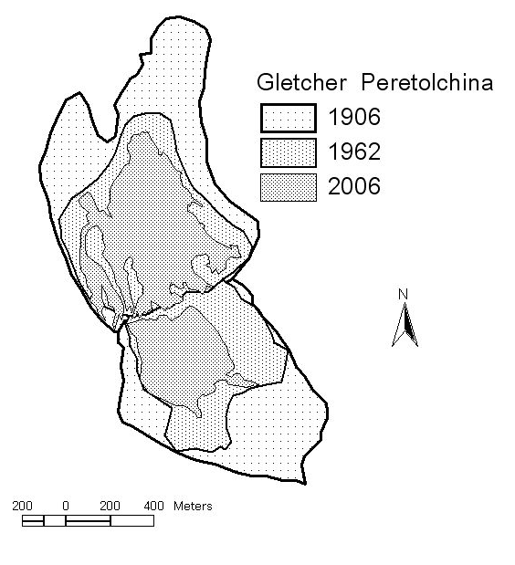
Fig. 3. Change stages of Peretolchin glacier according to the data of 1906, 1962 and 2006.

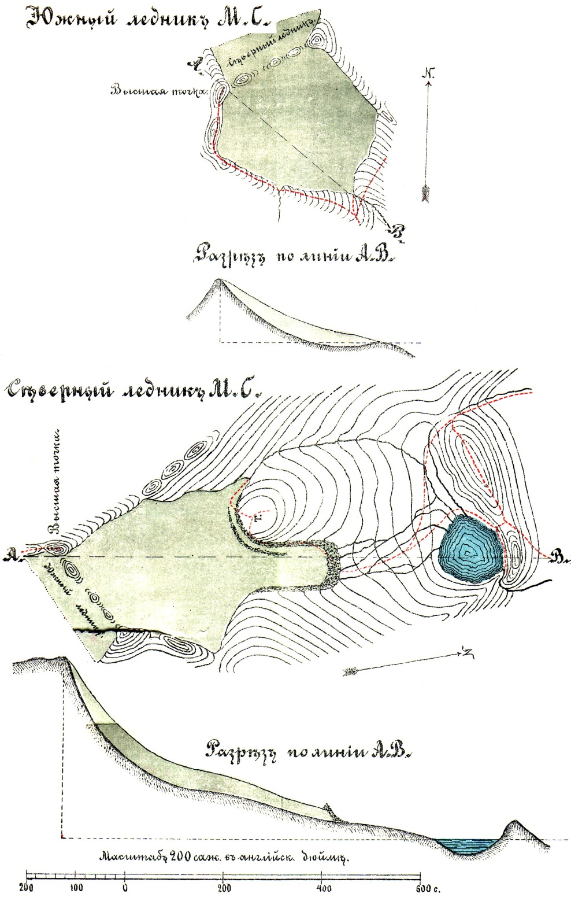
Fig. 4. The original scheme of Peretolchin glacier in 1906 [5]
The glaciers of the largest glaciations in the Eastern Sayan in the region of Topographers are not studied in detail with ground facilities, but the remote sensing data analysis of Landsat-ETM showed that they decreased significantly, and require refinement of their parameters, including the coordinates in the database WGI.
The glaciers of Barguzin and Baikal ranges have not been studied in detail previously and do not enter into the database WGI. In 2010, the expedition of the IG SB RAS examined Chersky glacier and the nearby Solnechny glacier. There was a trend of glacier reduction, but not as significant as in the massif Munku-Sardyk. Accordingly, the fields Code, GlacierName, Lat, Long, Area total have values (Table 3):
Table 3
SU5B16000001 | Chersky | 55,056 | 108,698 | 0,407
SU5B16000002 | Solnechny | 55,042 | 108,699 | 0.179
According to the remote sensing data for half a century the main area of ​​the glacier (Chersky) has decreased from 0.446 to 0.407 square kilometers, i.e. by 8.7% .
In the Barguzin range several glaciers are marked on topographic maps and are deciphered according to the remote sensing data by the Landsat-ETM. They have the same code structure as well as they are located within the sources of the rivers Tampuda and Svetlaya - the tributaries of Lake Baikal (the system of the Yenissei river). The largest from the group of glaciers Tampuda-Svetlaya (Barguzin) has coordinates Lat = 55,455; Long = 110,362. Its area has decreased from 0.271 to 0.18 square kilometers for 50 years, and at the beginning of last century it was probably one of the cliff glaciers in the nearby car.
As a typical glacier of the Kodar ridge Azarovoy glacier has been studied since the middle of century (Fig. 5). The parameters of this glacier in the database WGI also require clarification. The table 4 presents a comparative metadata of Azarovoy glacier.
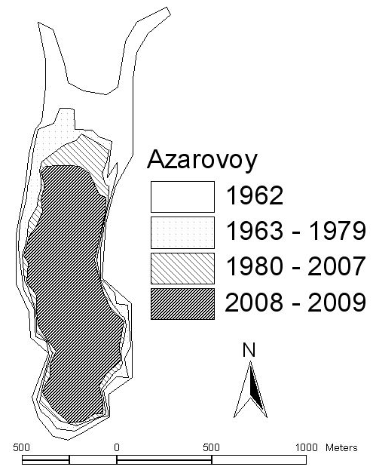
Fig. 5. Azarovoy glacier (Kodar ridge). Stage until 1962, 1979, 2007 and 2009.
Table 4
Code | Glacier name |  | Lat |  |  | Long |  | Topo year |  | Photo type |  | Photo year
SU5D17201020 | AZAROVOY |  | 56,888 |  |  | 117,578 |  | -99 |  | EROS, QB |  | 2007, 2009
Code | Total area | Area accuracy |  | Area exposed | Area ablation |  | Max length |  | Max length ex |  | Orientation ac |  | Orientation ab
SU5D17201020 | 0,45226 (1,3) | 0,7%  (1%) |  | 0,45226 (-99) | 0,45226 (-99) |  | 1,353  (2,0999999) |  | 1, 3  (1,89) |  | 358 |  | 360
Code | Max elev | Mean elev |  | Min elev | Min elev ex |  | Classification |  | Area ex1 |  | Area ex2 |  | Area ex3
SU5D17201020 | 2480  (2320) | 2312  (2160) |  | 2145  (2000) | 2200  (2200) |  | 640110 |  | 0,6673 |  | 0,5461 |  | 0,4522

Dynamics change in the area (Fig. 6) on the trend line says that its reduction slows down and the area must be stabilized by the middle of this century. However, the sharp decrease in ice thickness can affect its weight.
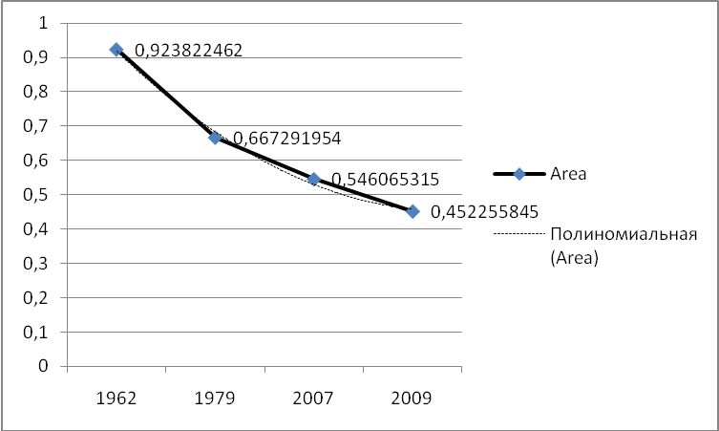

Fig. 6 Change of the area of Azarovoy glacier for 50 years, according to the topographic map (1962), photomapping (1979), the ERS (EROS-B, 2007) and (QuickBird, 2009).
Update of the existing database structure with current indices, parameters for different time stages of the study of nival-glacial sites, including those obtained by remote sensing data, as well as support with geospatial imaging will allow more detailed analysis and forecast changes in mountain landscapes and climate.

Bibliography
- http://www.webgeo.ru/index.php?r=47&id=38
- http://www.ngdc.noaa.gov/wdc/usa/glaciology.html
- http://www.westra.ru/reports/glacierinventory.html
- Kitov A.D., Plyusnin V.M. Features of local glaciological phenomena in mountainous landscapes (as exemplified on the Baikal-Urumqi transect) / / Sustainable Development of Territories: GIS theory and practical experience. Proceedings of the international conference. InterCarto-InterGIS - 14, Saratov, Urumqi, June 24-26, 2008, Volume 1. - Saratov: International Cartographic Association, 2008, - p. 130-137.
5. Peretolchin S.P. Glaciers of Munku-Sardyk range.- Tomsk: Tipo-lithography of Sib. Typography, 1908 .- 60 p.

