Investigation of coherent structures in a strongly swirling jet undergoing vortex breakdown

S.S. Abdurakipov^{1,2}, V.M. Dulin^{1,2}, D.M. Markovich^{1,2*}
¹S.S. Kutateladze Institute of Thermophysics, Siberian Branch of Russian Academy of Sciences, Novosibirsk, Russia
²Novosibirsk State University, Novosibirsk, Russia
*e-mail address: dmark@itp.nsc.ru
This work was fulfilled under foundation by Government of Russian Federation (Grant No. 11.G34.31.0035)

Swirling jet flows are widespread in a number of industrial devices: open burners, combustion chambers, mixers, etc. From a practical point of view, the imposed swirl can essentially enhance mixing processes in devices that utilise jet flow configurations. In particular, swirl is often used for stabilization of flames. However, even for non-reacting swirling jets, substantially different flow regimes can be observed, depending on the swirl rate and the manner in which the swirl is applied. While vortex rings, resulted from growth of Kelvin–Helmholtz instability, prevails mixing layer of non-swirling and weakly swirling jets, strong helical waves become dominant in the shear layer of the jet with a sufficiently high swirl rate. A further increase in the swirl rate leads to the breakdown of the swirling jet's vortex core, which has been observed in different states: spiral, bubble, and conical, where the latter two can be either symmetric or asymmetric. Remarkable, that flow structure of strongly swirling jets with bubble-type breakdown and precession of the vortex core manifests some common features, even for rather different nozzle geometries, since the flow is absolutely unstable to a self-excited/globally unstable to (co-rotating counter-winding) helical wave [1]. This coherent structure dominates dynamics of the flow. Proper Orthogonal Decomposition (POD) is an efficient statistical tool for fluid mechanics [2] to extract coherent structures in turbulent ﬂows. Application of the method to a large set of instantaneous velocity fields can significantly reduce the dimensionality of the problem by obtaining a set of temporal and spatial basis functions (main modes), which contain the largest amount of kinetic energy of the flow. Thus, in the present work POD was utilized to investigate shape and intensity of coherent structures in a strongly swirling jet undergoing a bubble-type vortex breakdown (VB). A stereo Particle Image Velocimetry (PIV) was used for the measurements of the 1 000 instantaneous velocity fields, which were processed by the snapshot POD algorithm [2]. The measurements were performed in a hydrodynamic loop described in details in [3]. A nozzle with exit diameter d = 15 mm was used for organization a strongly swirling jet flow with a pronounced VB and bubble-type recirculation zone. The swirl rate based on geometry of the nozzle was S = 1.0. Details of the experiment, measurement method and flow structure are described in [3]. Analysis of the first two (most powerful) POD modes for the flow revealed that they contain almost 20% of the turbulent kinetic energy and correspond to precession of the jet's vortex core and a couple of secondary helices formed in the inner and outer mixing layers of the jet. Plotted in Fig. 1 3D structure of coherent vortices was reconstructed on the basis of the first two POD modes (by analogy with [1, 4]) and visualized by isosurfaces of λ₂-criterion [5]. Vortex core (2), outer (3) and inner (4) secondary spiral vortices are clearly visible. These secondary vortices are left-handed spirals (sense of winding opposite to the mean flow rotation), which are similar to these reported in [1]. The obtained results are in a good agreement with phase-averaged LDA data by [6], where two secondary helices were found to be induced by precession of the swirling jet core.
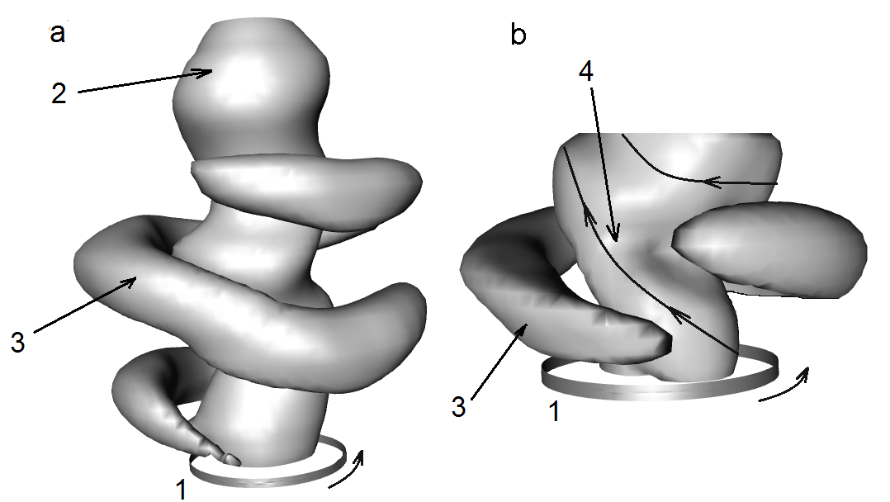
Fig. 1. 3D spatial structure of large-scale vortices in a strongly swirling jet with bubble-type VB. The structure was reconstructed on the basis of two most powerful POD modes and visualized by isosurfaces of λ₂-criterion [5] a) λ₂=-40000 b) λ₂=-70000. 1 – Nozzle exit; 2 – Swirling core of the jet; 3 – Secondary vortex induced in the outer mixing layer; 4 – Inner spiral vortex. The Reynolds number was 8 900, the swirl rate was 1.0 [3].
References
[1] K. Oberleithner, M. Sieber, C.N. Nayeri, et al, "Three-dimensional coherent structures in a swirling jet undergoing vortex breakdown: stability analysis and empirical mode construction", J. Fluid Mech. 679. 383-414 (2011).
[2] P. Holmes, J.L.Lumley, G. Berkooz, Turbulence, coherent structures, dynamic systems and symmetry, (Cambridge University Press, 1996).
[3] S.V. Alekseenko, V.M. Dulin, Yu.S. Kozorezov, et al, "Effect of axisymmetric forcing on the structure of a swirling turbulent jet", Int. J. Heat Fluid Flow. 29(6). 1699-1715 (2008).
[4] M. Stohr, R. Sadanandan, W. Meier, "Phase-resolved characterization of vortex-flame interaction in a turbulent swirl flame", Exp. Fluids. .51(4), 1153-1167 (2011).
[5] J. Jeong, F. Hussain, "On the identification of a vortex", J. Fluid Mech. 285. 69-94 (1995).
[6] C.E. Cala, E.C. Fernandes, M.V. Heitor, et al, "Coherent structures in unsteady swirling jet ﬂow", Exp. Fluids. 40(2). 267-276 (2005).

